3A M1 Test
Class_____ Name________ No._____ Mark________
Listening:50%
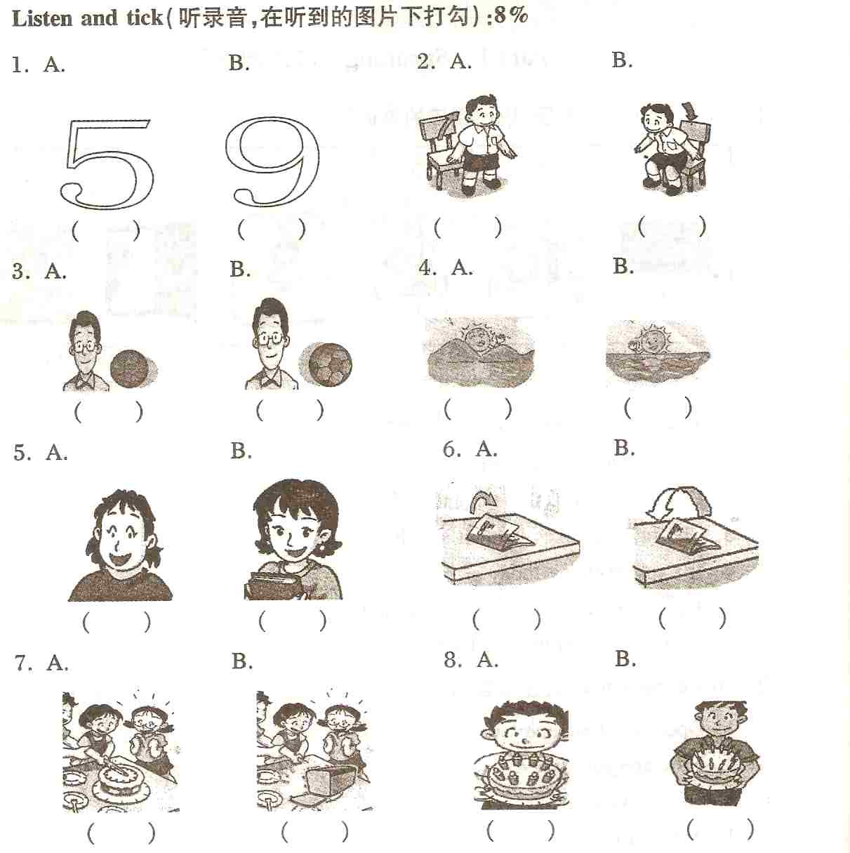

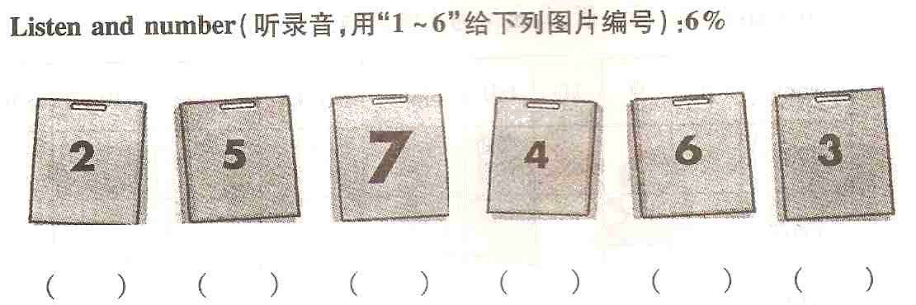
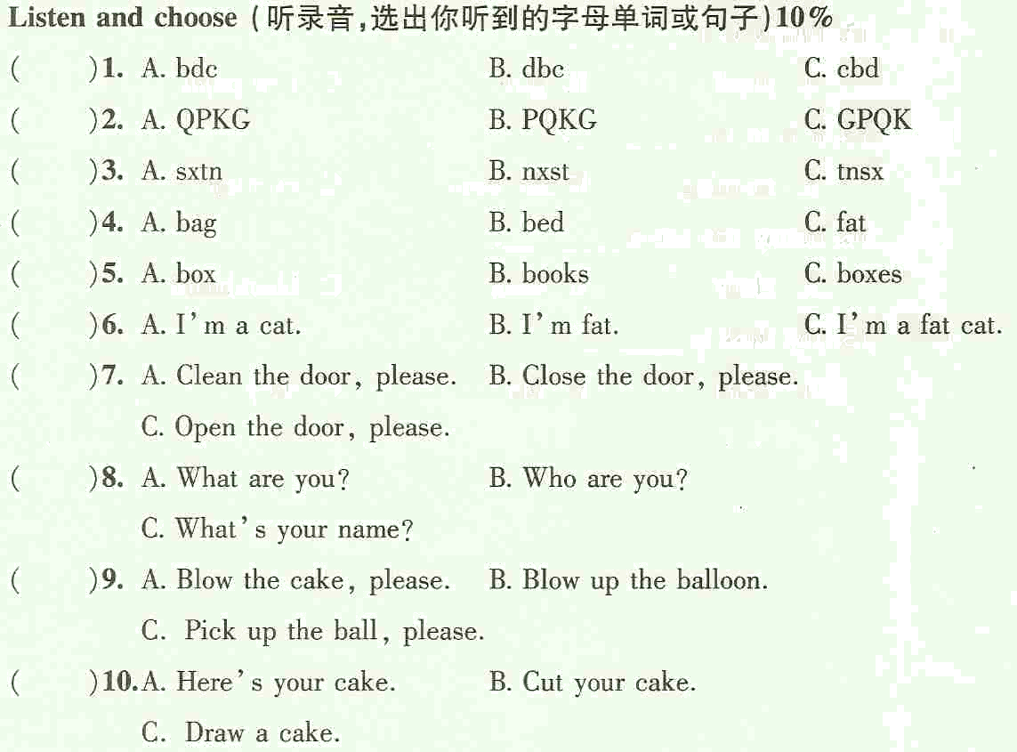
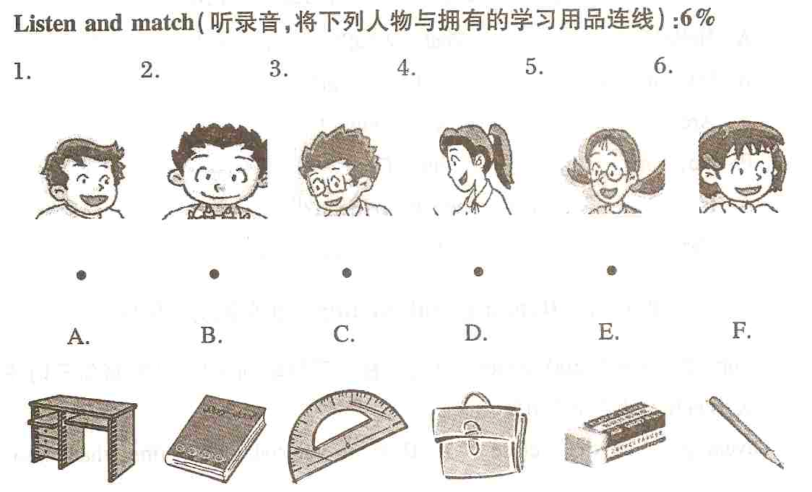
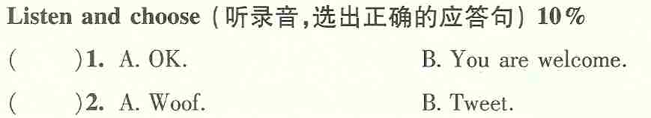
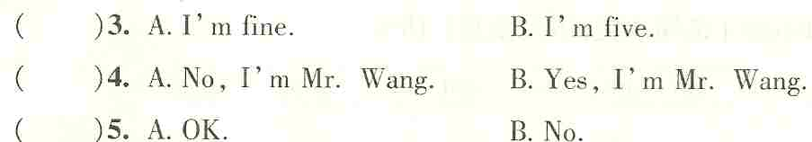
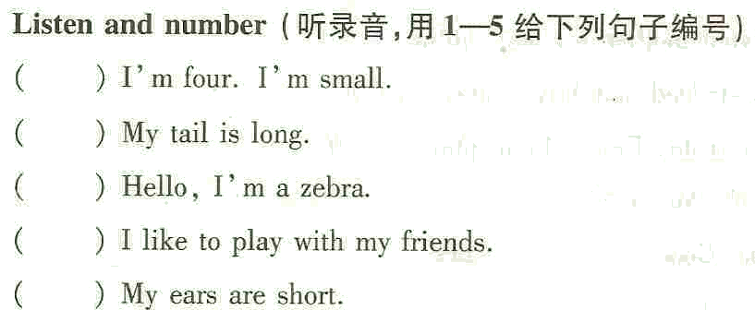
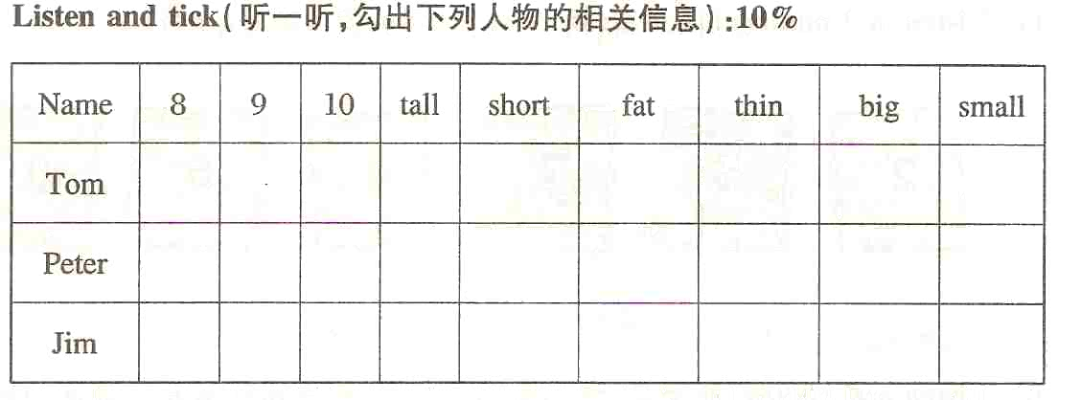
Reading and writing:50%
I. Copy the sentences（正确抄写下列句子，注意大小写和标点）8%
1. how are you today fine thanks
__________________________________________________________________
2. close the window please ok miss fang
__________________________________________________________________
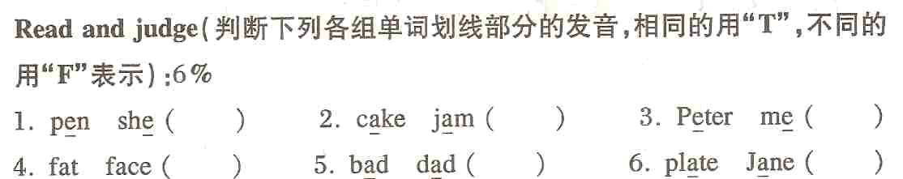
II.

III. Read and choose（选出不同类的单词）6%
( ) 1. A. Alice B. Ben C. Eddie D. Danny
( ) 2. A. morning B. afternoon C. night D. good
( ) 3. A. to B. nine C. two D. six
( ) 4. A. elephant B. jam C. mouse D. lion
( ) 5. A. sit B. down C. stand D. open
( ) 6. A. Mr B. Miss C. Mrs D. Mum
IV. Read and choose（选择题）12%
( ) 1. Hello, I _____ Kitty Li. A. am B. is C. are
( ) 2. Here _____ your cake, Peter. Thanks, Mum. A. am B. is C. are
( ) 3. _____ you eight? No. I’m nine years old. A. am B. is C. are
( ) 4. This _____ my new teacher, Miss Green. A. am B. is C. are
( ) 5. Look _____ the tree. It’s big. A. at B. to C. for
( )6. I can count _____three. One, two, three. A. at B. to C. for
( ) 7. Alice，here’s a present _____ you. A. are B. to C. for
( ) 8. She is our new teacher, _____ White. A. Mr B. Mrs C. Miss
( ) 9. _____ are you? I’m eight. A. How B. What C. How old
( )10. Can your mother ride a bicycle? No, she ___. A. can’t B. isn’t C. don’t
( ) 11. It’s cold today. Please ____ the window. A. open B. close C.clean
( ) 12. Kitty, _____ the blackboard, please. OK. A. open B. close C.clean
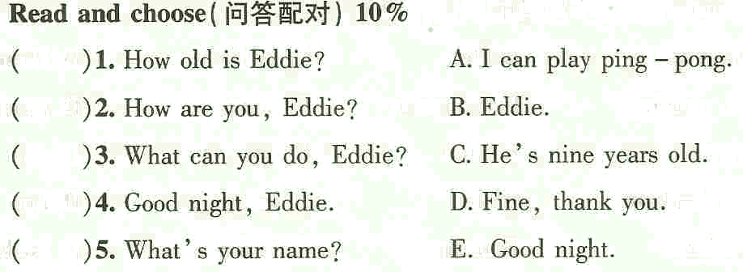
V.

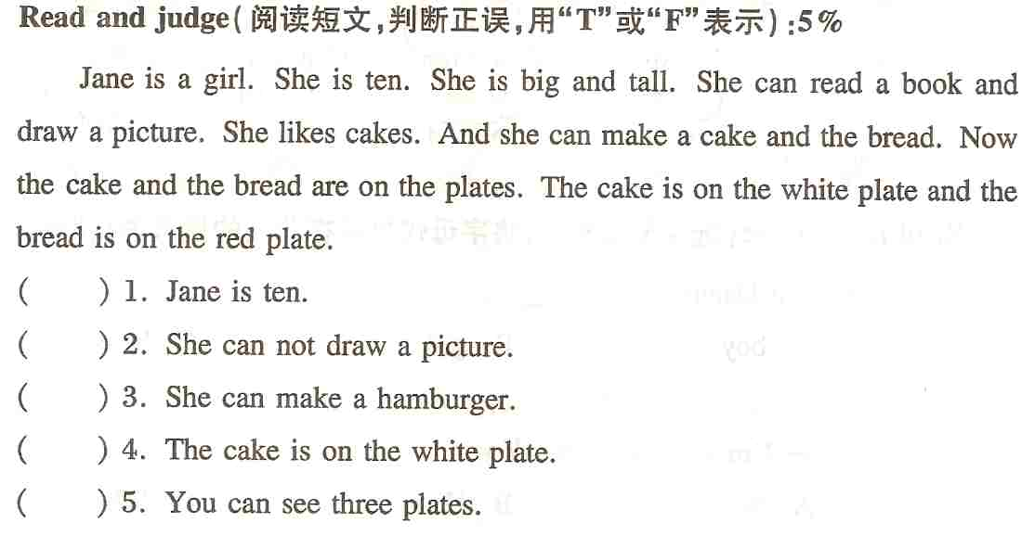
VI.

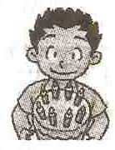

VII. Look at the picture and write（看图完成句子）8%
Hello, I’m ____________.I’m a ____________.
I’m ____________ years old. I’m _________ and ___________.I can _____________ basketball. Today is my ____________.I’m ____________.

听力部分
I．听录音，在听到的图片下打勾

II．听录音，选出你听到的字母、单词或句子
1. bdc(A) 2. PQKG(B) 3. tnsx(C) 4. bed(B)
5. biiks(B) 6. I’m a fat cat.(C) 7. Clean the door, please.(A)
8. What’s your name? (C) 9. Blow up the balloon.(B)
10. Here’s your cake. (A)

III. 听录音，用1-6给下列图片编号

IV．听录音，将下列人物与拥有的学习用品连线

V. 听录音，选出正确地应答句
1. Thank you.(B) 2. Listen to the dog. (A)
3. How old are you? (B) 4. You’re Mr Wang. (B)
5. Open the books,please. (A)

VI. 听录音，用1-5给下列句子编号
Hello, I’m a zebra. I’m four. I’m small. My tail is long. My ears are short. I like to play with my friend.
( 2 3 1 5 4 )

VII．听一听，勾出下列人物的相关信息

