3A M2 Test
Class_____ Name_______ No._____ Mark______
Listening
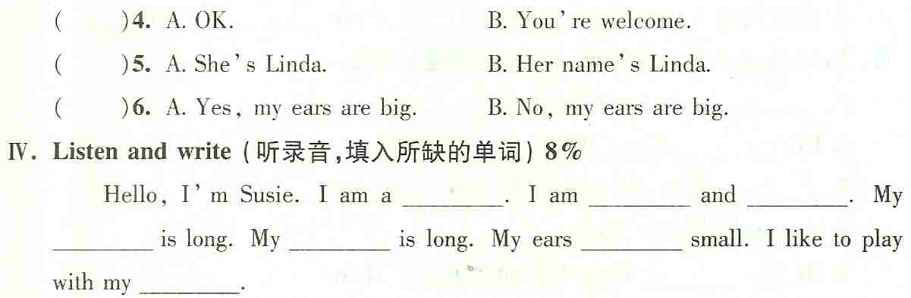
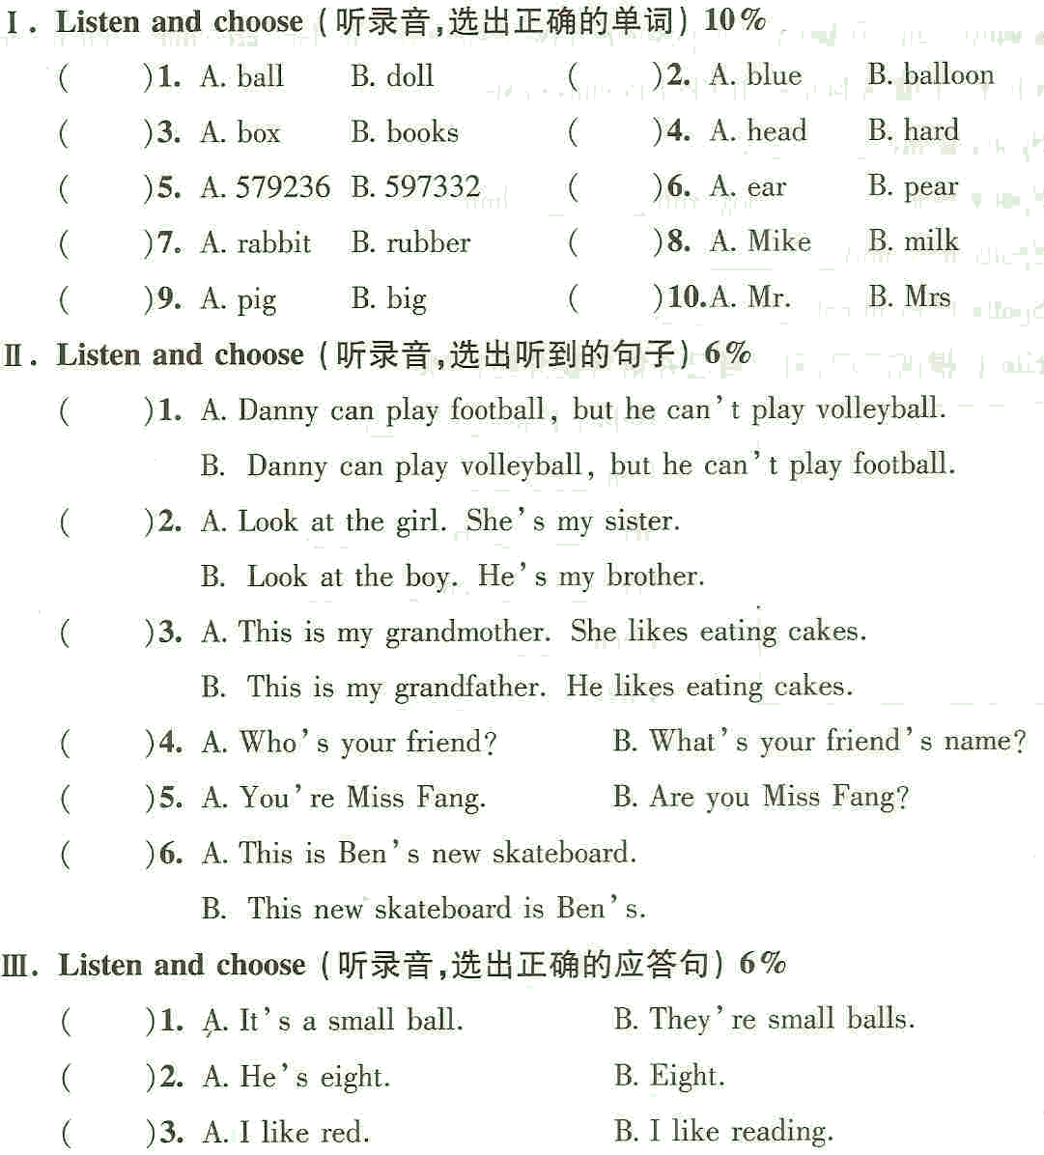

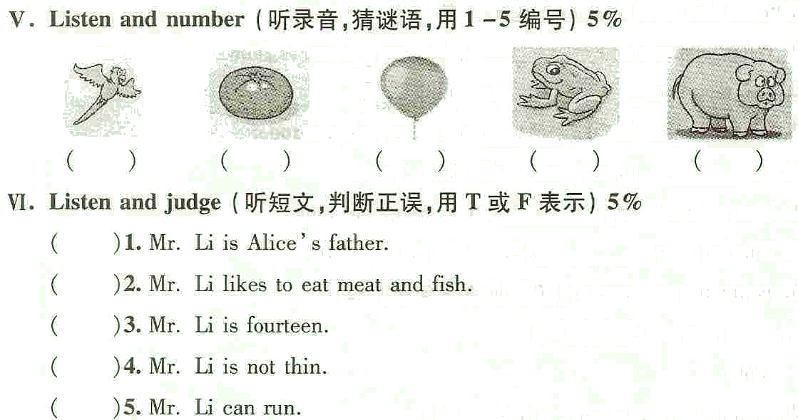
Reading and writing:
I. Copy the sentenses（正确抄写下列句子，注意大小写和标点符号）4%
this is my grandfather his name is paul
___________________________________________________________________
II.
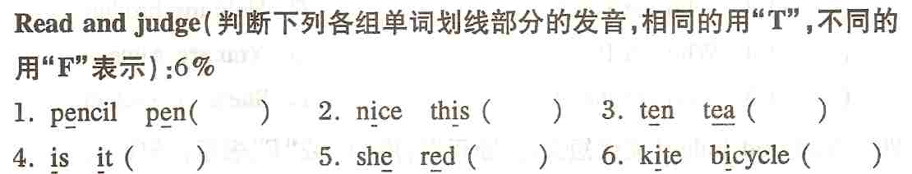

III.
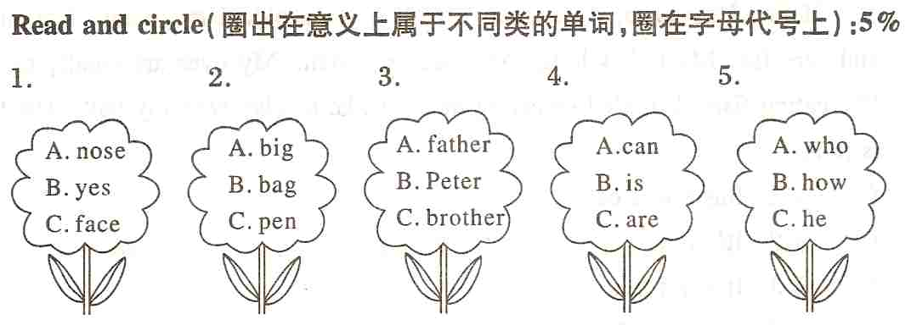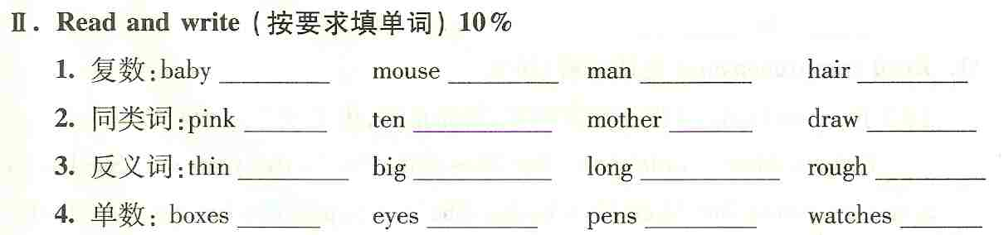
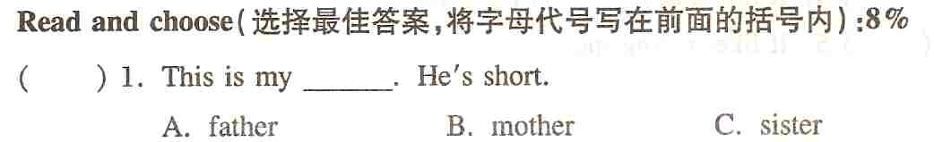
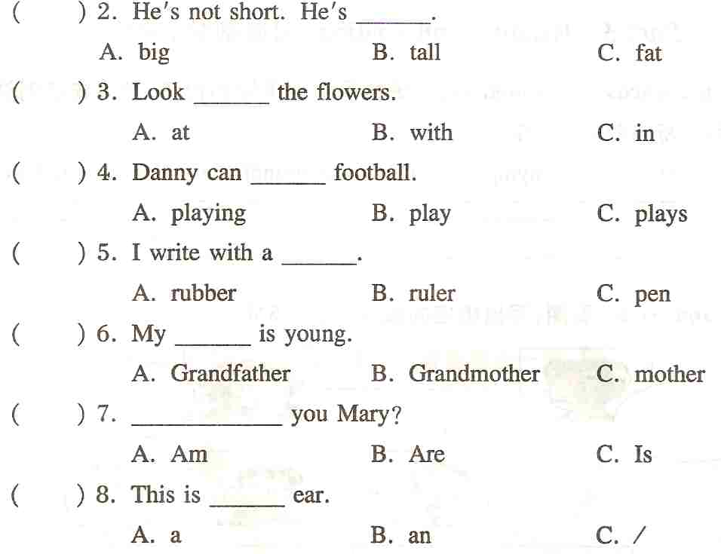
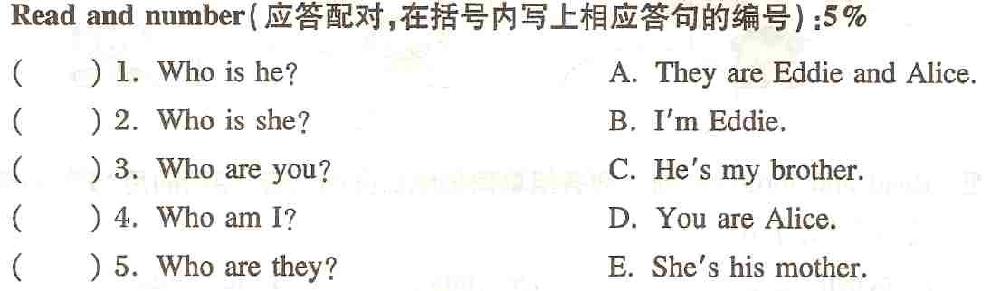
VII. Read and judge（阅读短文判断， 用T 或F表示）5%
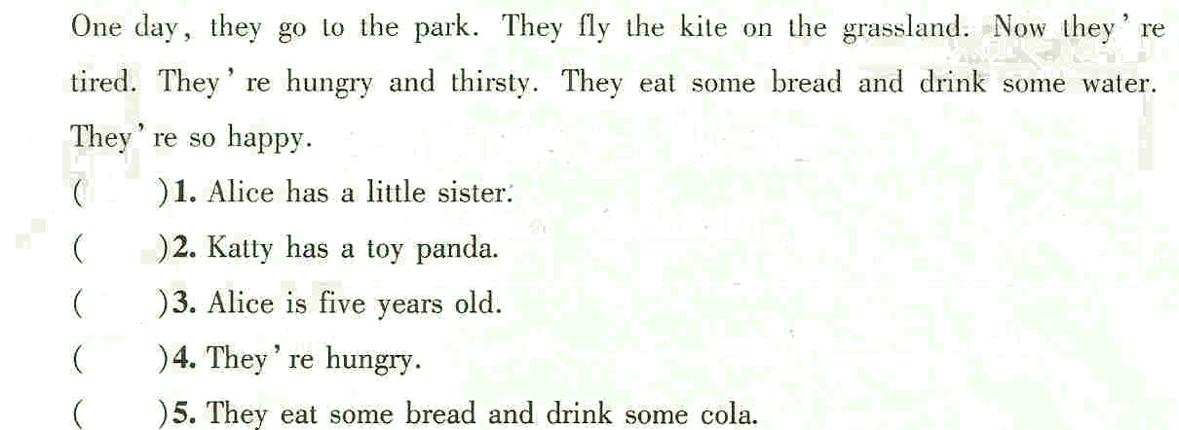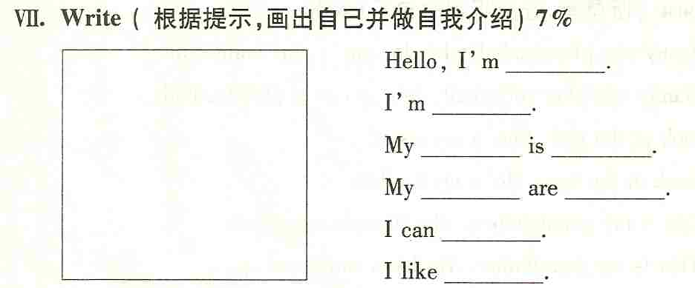

听力内容：
