3A Module 4 Test
Class____ Name________ No.____
Listening: 47%
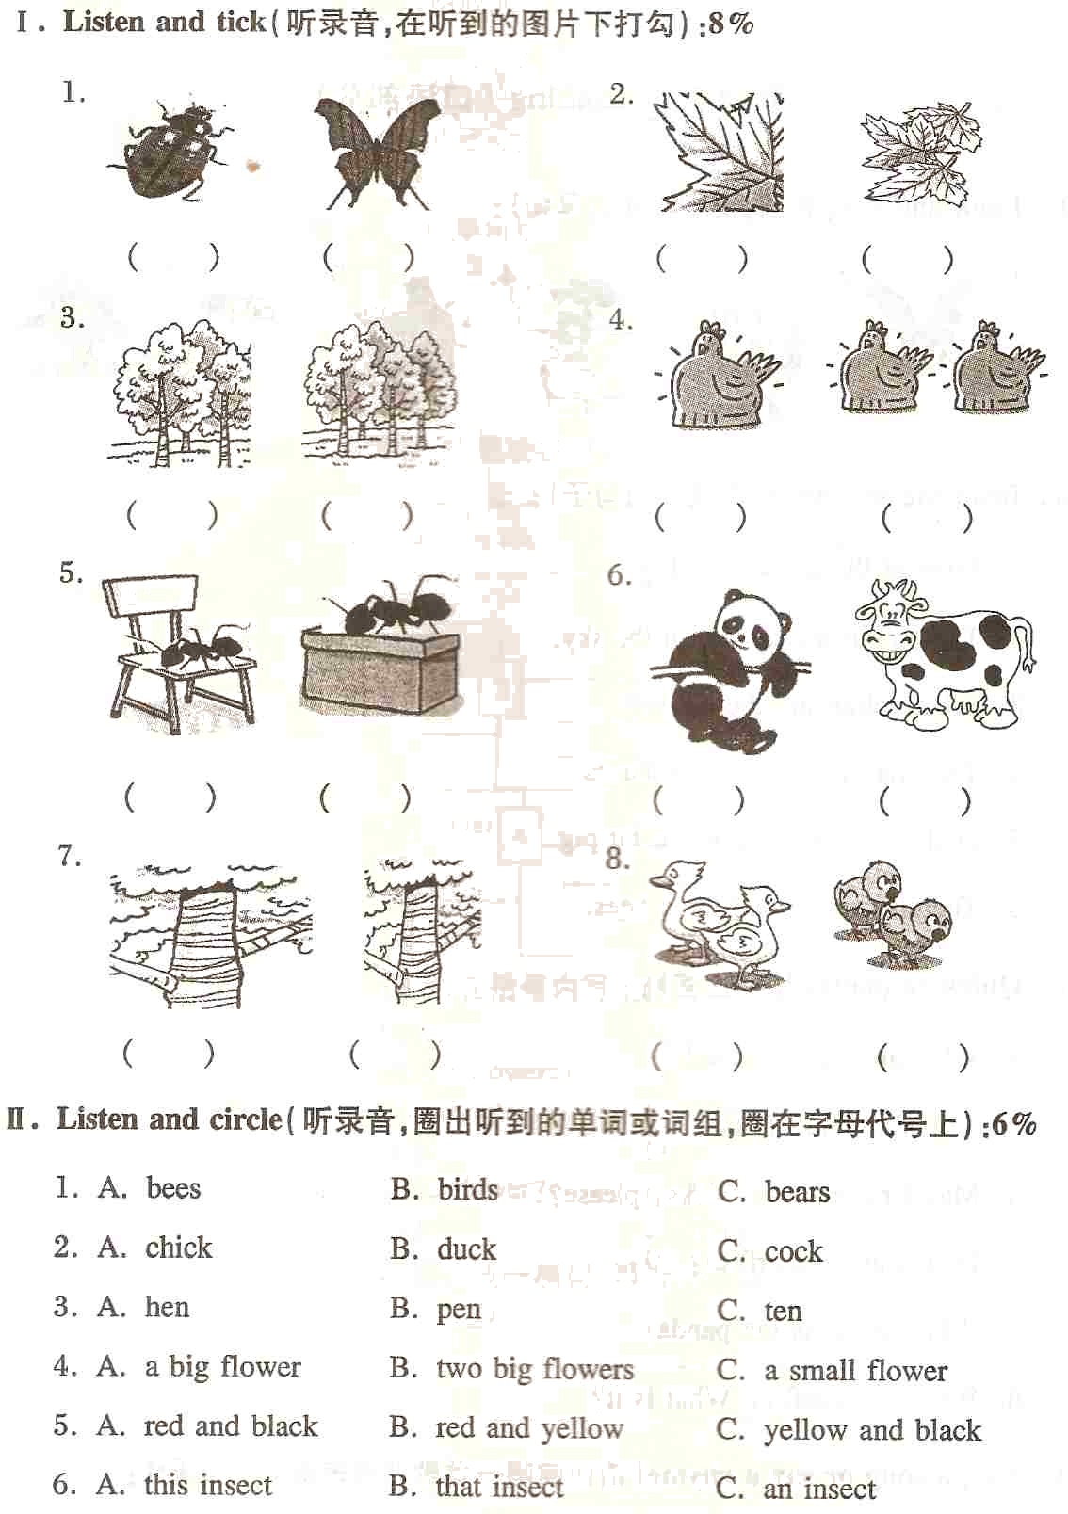
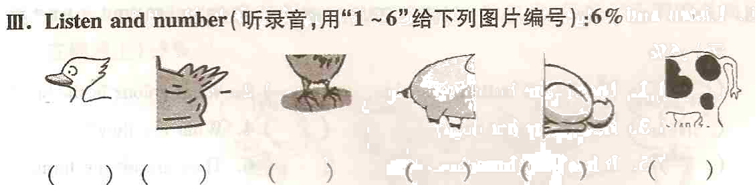
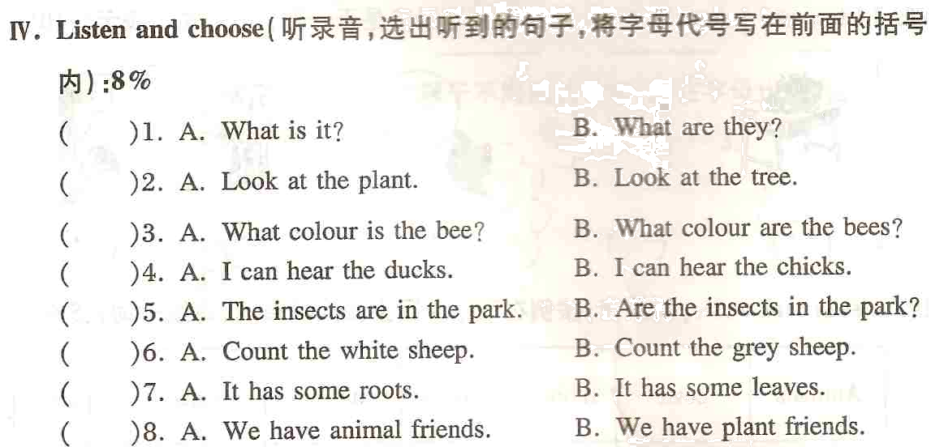
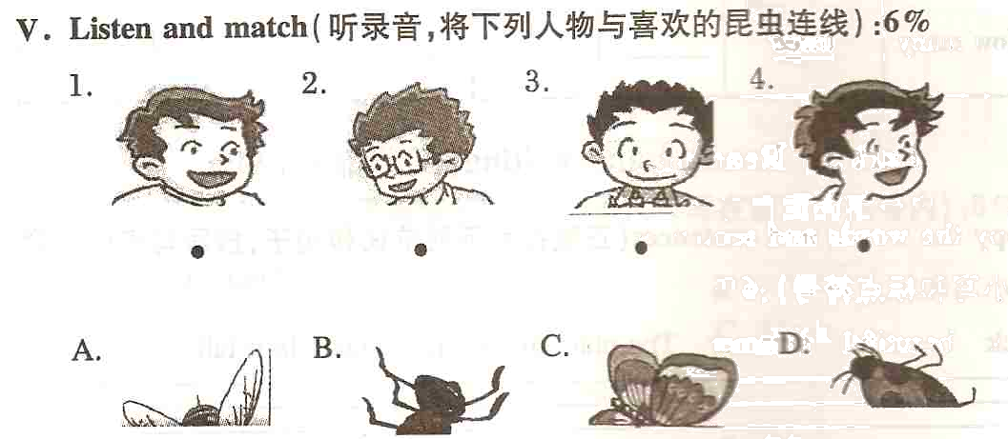
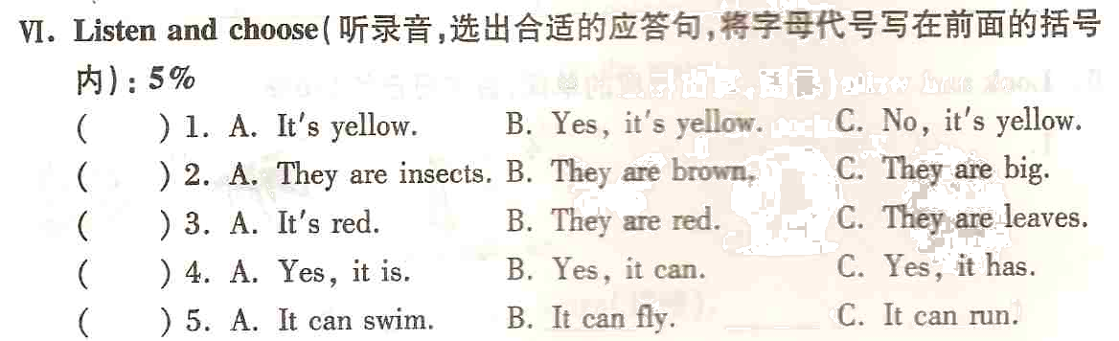
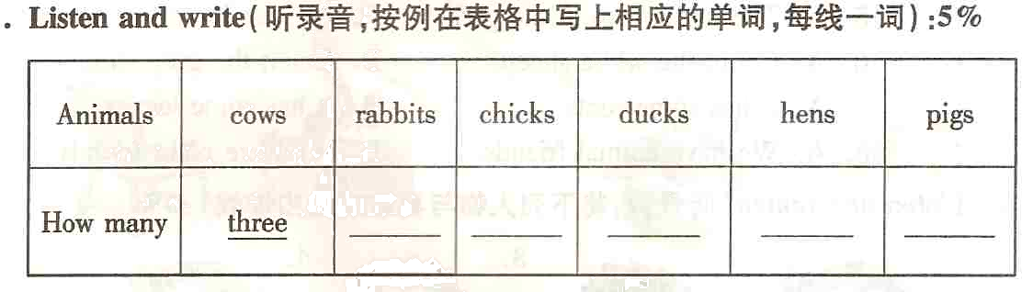
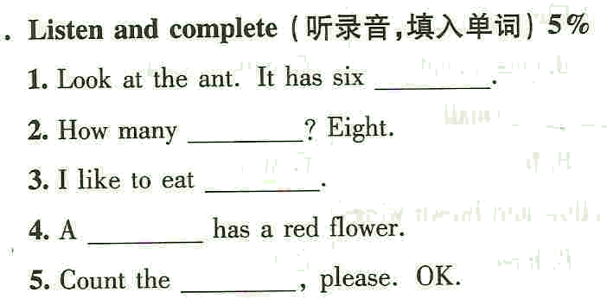
Reading and writing: 53%
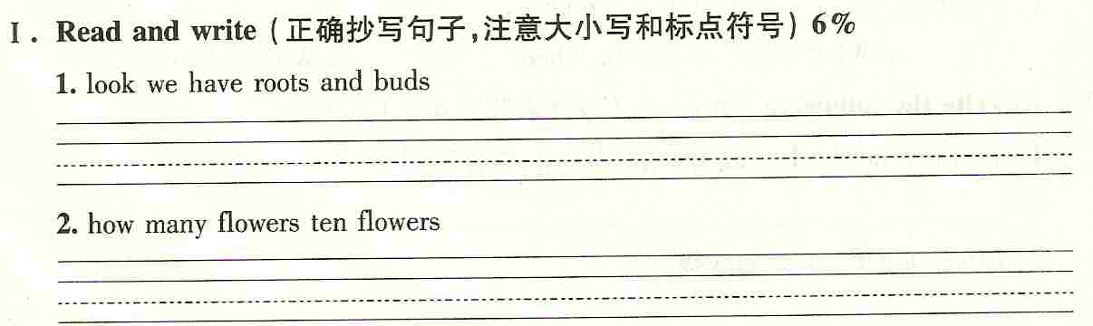
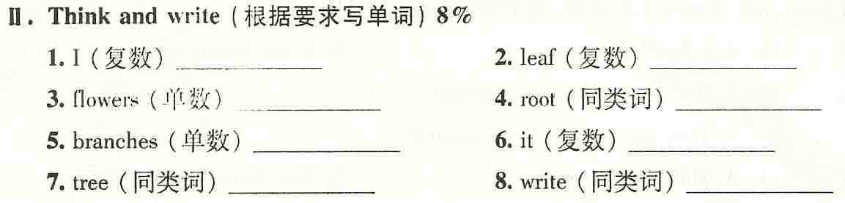
III. Read and circle（写出在意义上属于不同类的单词的编号）5%
( ) 1. A. bee B. blue C. brown
( ) 2. A. root B. leaf C. book
( ) 3. A. dog B. fat C. small
( ) 4. A. is B. can C. are
( ) 5. A. play B. has C. fly
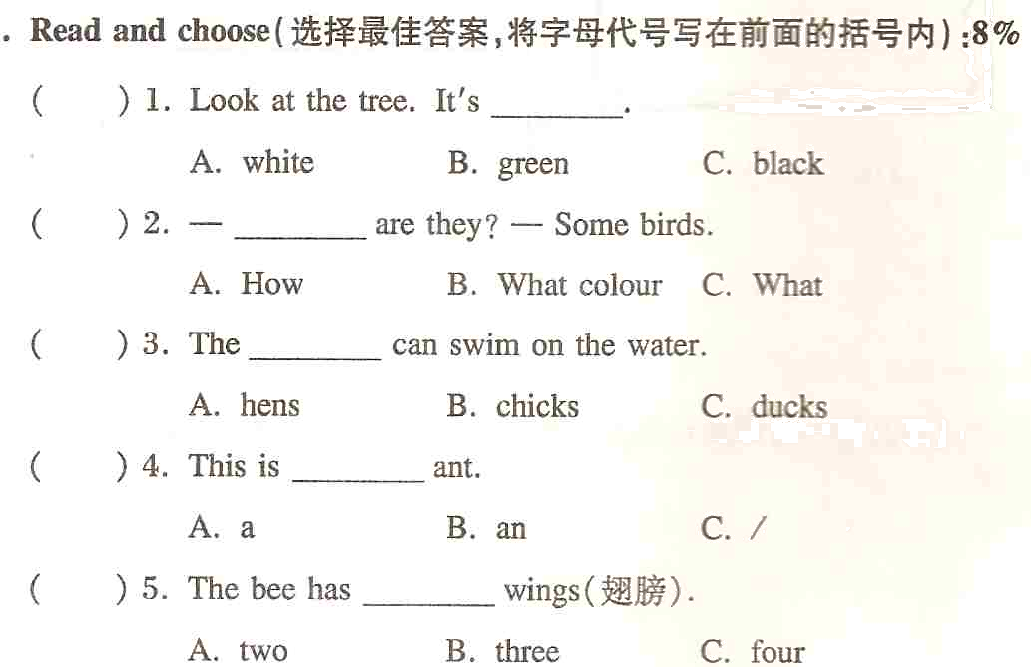
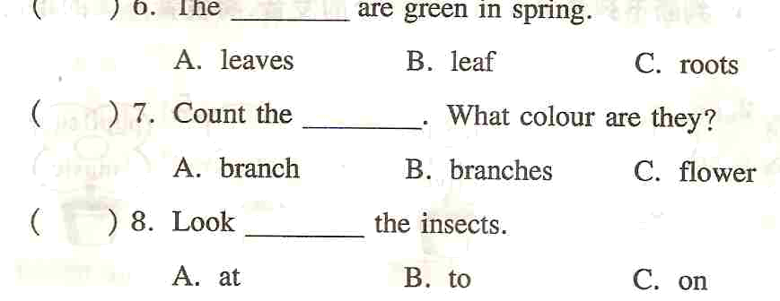
V. Fill in the blanks（用am, is, are 和has填空）8%
1. This ____ an insect. It ___ a head. It ____a body. It ____ six legs.
2. What colour _____ the kites? They ______ blue.
3. ______ you a boy? No. I ______ a girl.
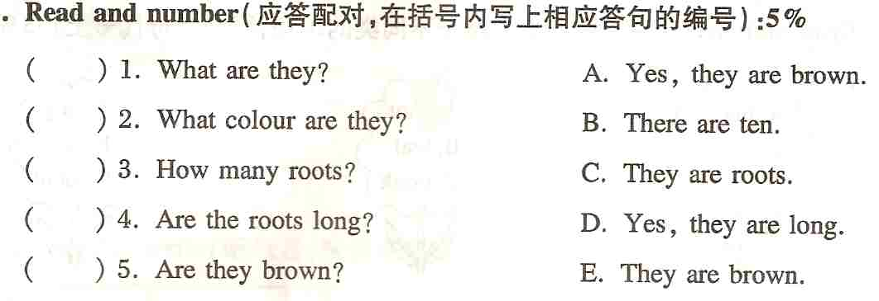

VII. Read and judge（阅读短文，用T或F判断）5%
It’s Sunday afternoon. Some pupils are in the park. They are so happy! The flowers are very beautiful. They are pink and yellow. Look, what’s this? It’s a ball. It’s small and blue. Look at the birds! They are small. I like birds.
( ) 1. It is in the morning.
( ) 2. The blue and yellow flowers are beautiful.
( ) 3. The pupils are happy.
( ) 4. The blue ball is big.
( ) 5. I like birds.
VIII. Write（以 A plant 为题，写写你喜欢的一棵植物）8%
A plant
_________________________________________________________________________________________________________________________________________________________________________________________________________________________________________________________________________________________________________________________________________________________

