3B M1U1 周练卷1
Class____ Name________ No.____
Listening:
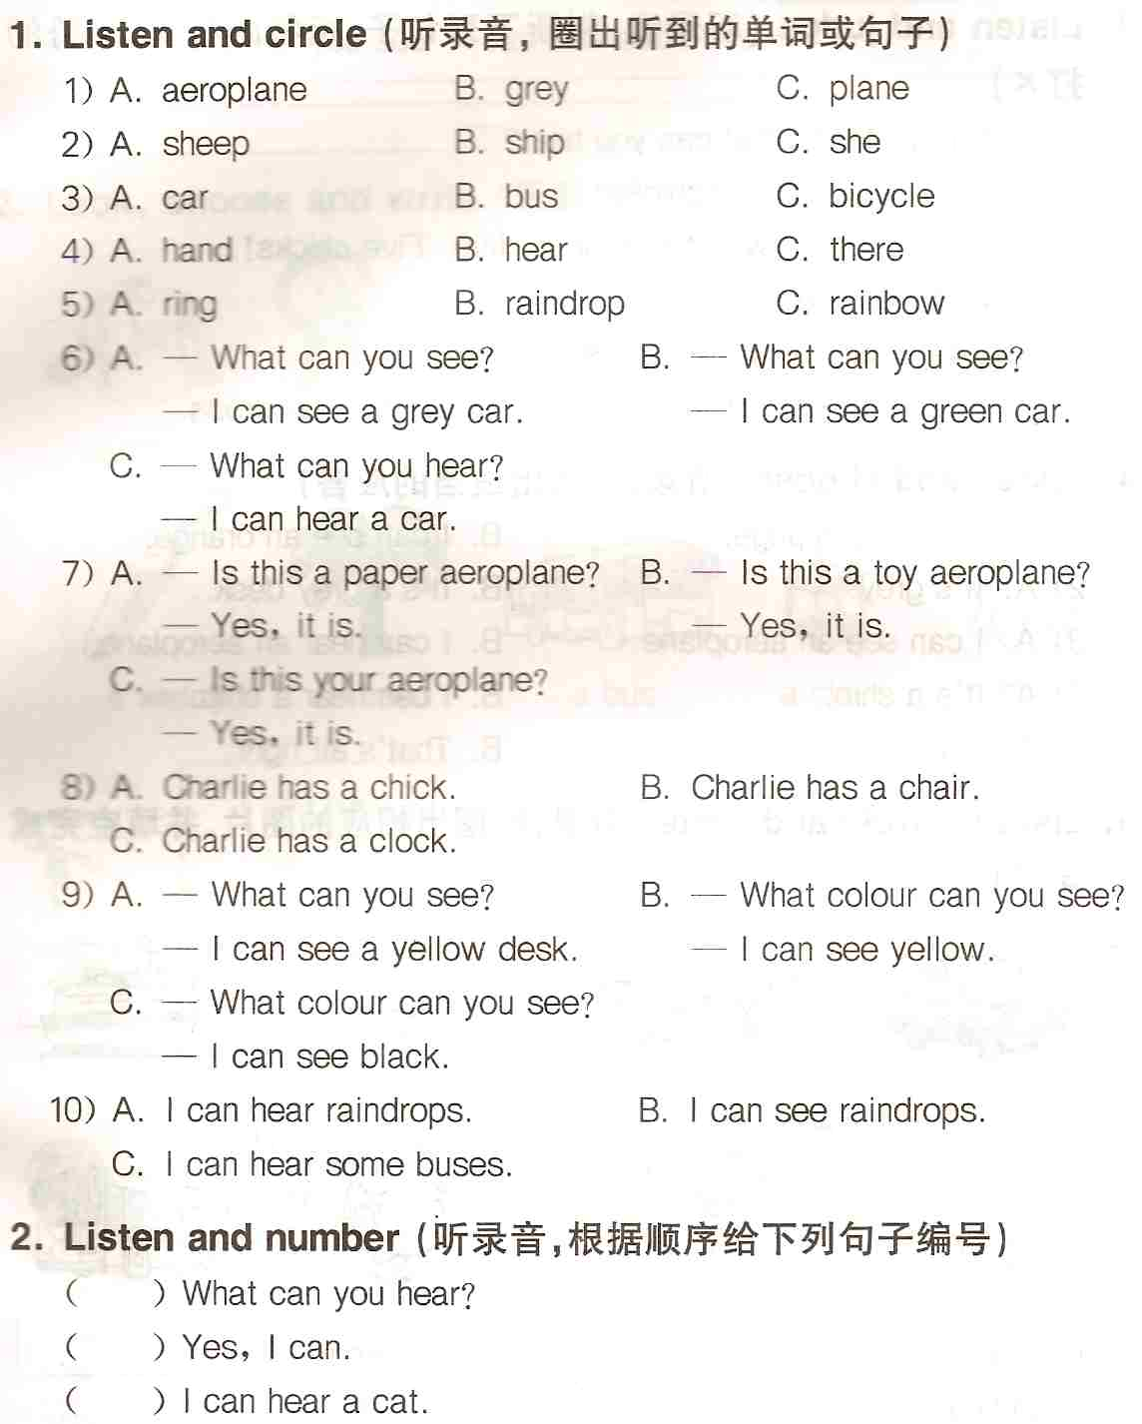
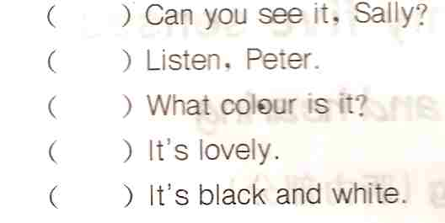
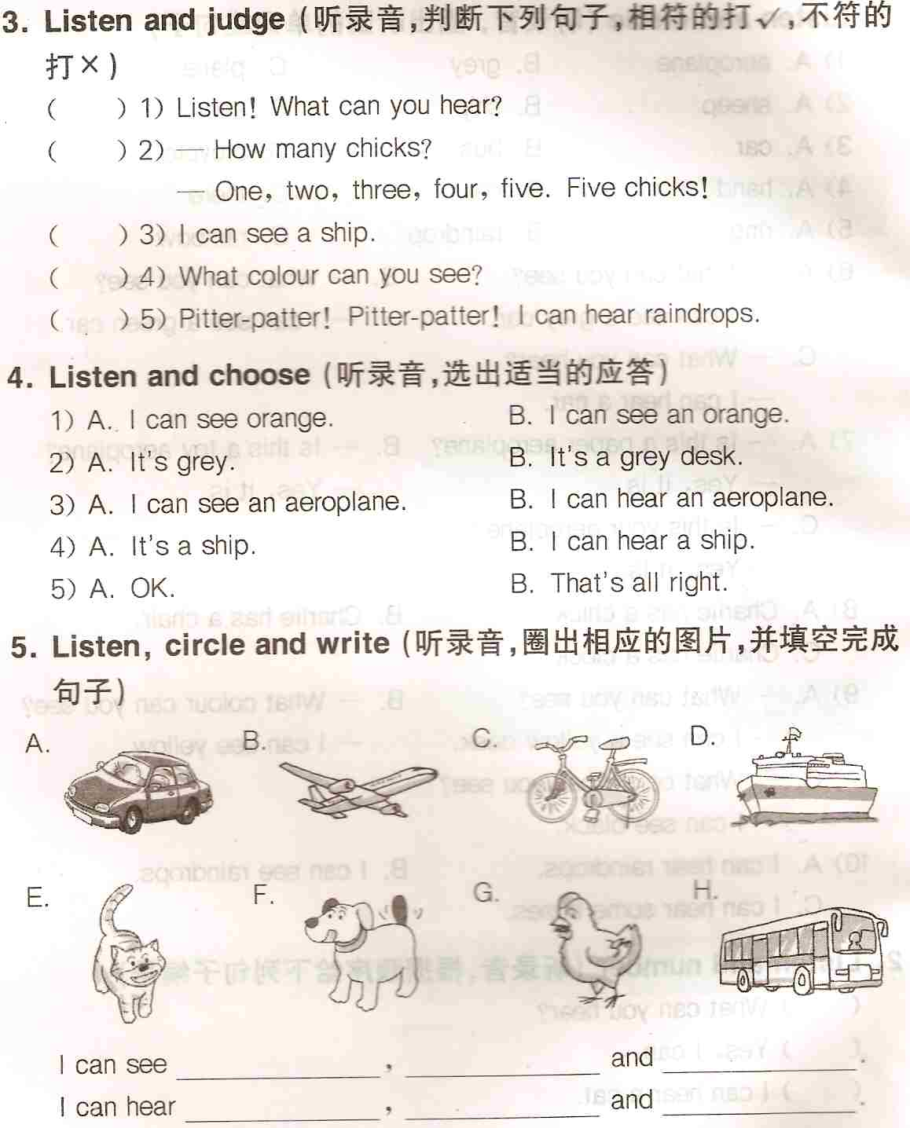
Reading and writing:
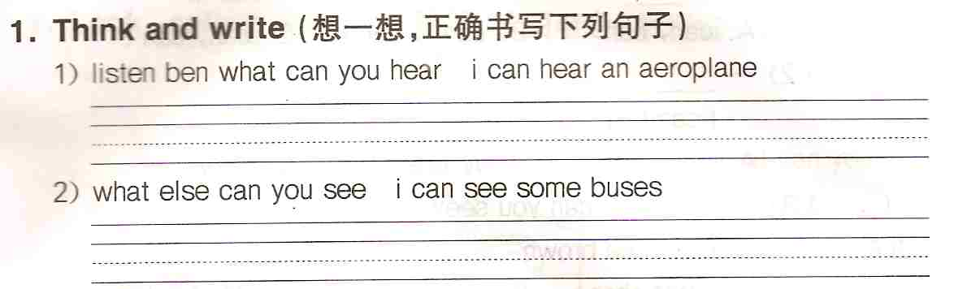
2. Look and choose（选出不同类的单词）
( ) 1) A. dog B. cat C. animal D. bird
( ) 2) A. see B. ear C. listen D. hear
( ) 3) A. bus B. van C. aeroplane D. car
( ) 4) A. make B. spin C. cut D. spinner
( ) 5) A. book B. table C. rubber D. ruler
3. Look and write（按要求写单词）
1）反义词：tall________ fat________ open________
black_______ big________ hard________
2）复数：bus________ baby________ leaf ________
car________ mouse________ child________
3）单数：birds________ ships________ libraries________
boxes_______ sheep________ trains________
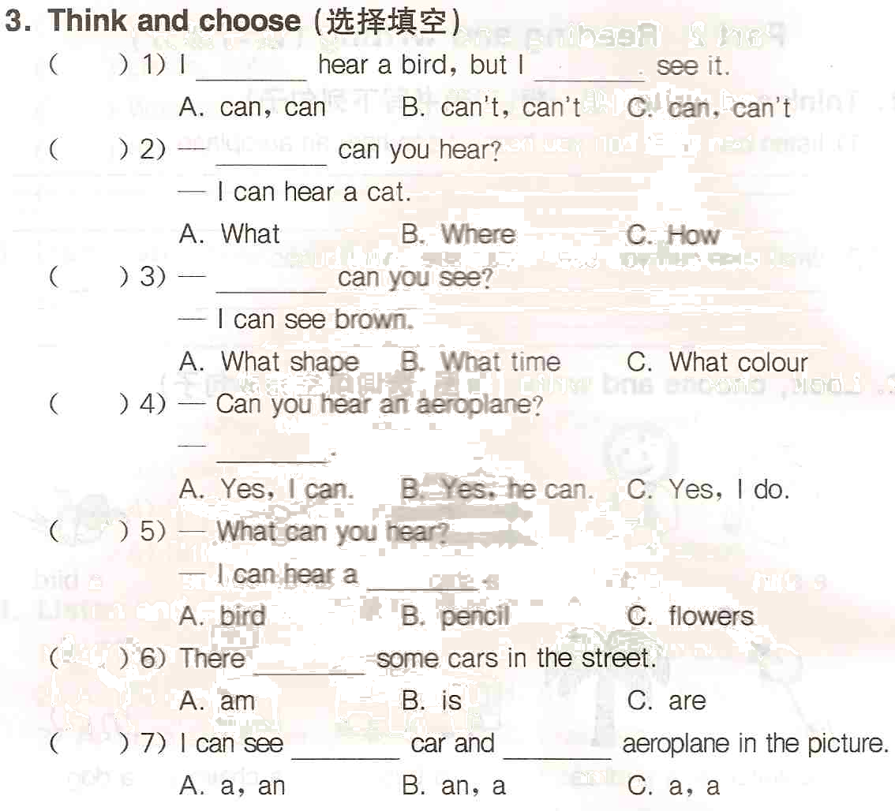
5. Fill in the blanks（用单词的适当形式填空）
1） Look！ There are two ________ (bus) in the street.
2) Give me some ________ (apple), please.
3) How many ________ (box)? Seven.
4) Is there an ________ (orange) on the table?
5) Are they ________ (bicycle)? Yes, they are.
6) Look at the yellow ________ (leaf). They are falling down.
6. Change the sentences（按要求改写句子）
1) I can see an aeroplane. （否定句）
____________________________________________________
2) Ben can hear a dig. （否定句）
____________________________________________________
3) I can see green. （对划线部分提问）
____________________________________________________
4) They can hear some cars. （对划线部分提问）
____________________________________________________
5) We can see three ladybirds. （一般疑问句）
____________________________________________________
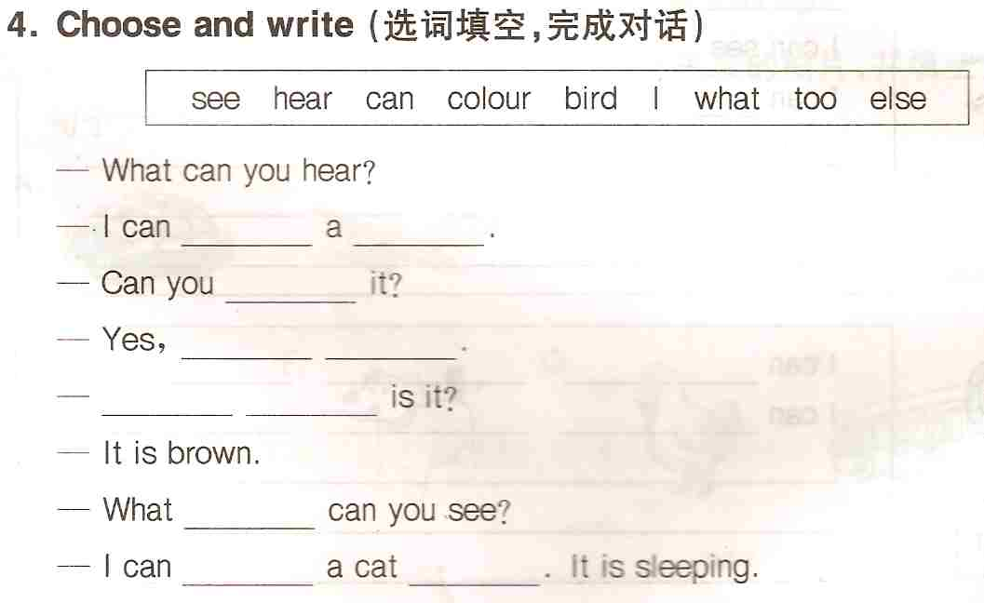
8. Read and match（问答句配对）
( ) 1. What can you hear? | A. It’s pink.
( ) 2. What colour can you see? | B. It’s a pink doll.
( ) 3. What’s this? | C. Yes, I can.
( ) 4. What colour is the doll? | D. Yes, it is.
( ) 5. Can you see a pink doll? | E. I can see pink.
( ) 6. Is this your doll? | F. I can see a pink doll.
( ) 7. What can you see? | G. I can hear a ship.

