3B M1U2 周练卷2
Class_____ Name__________ No._____
Listening:
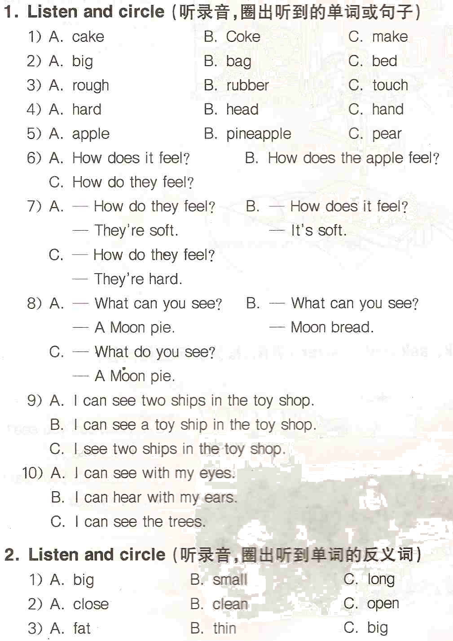
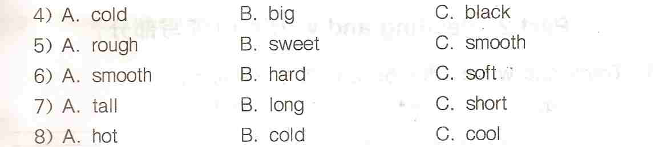
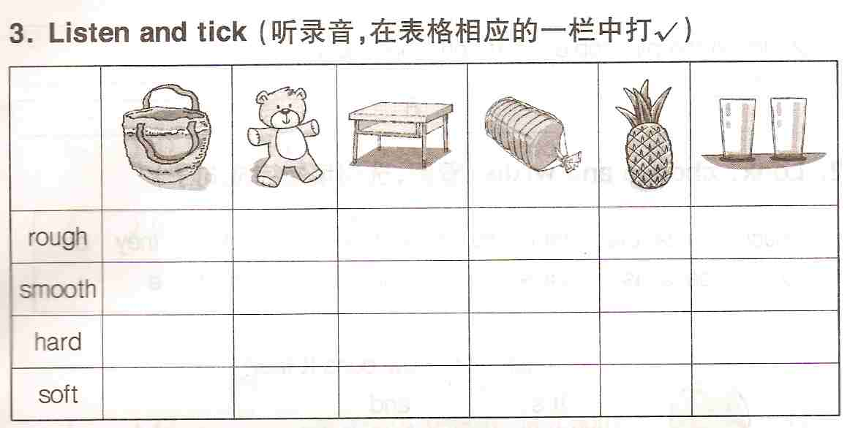
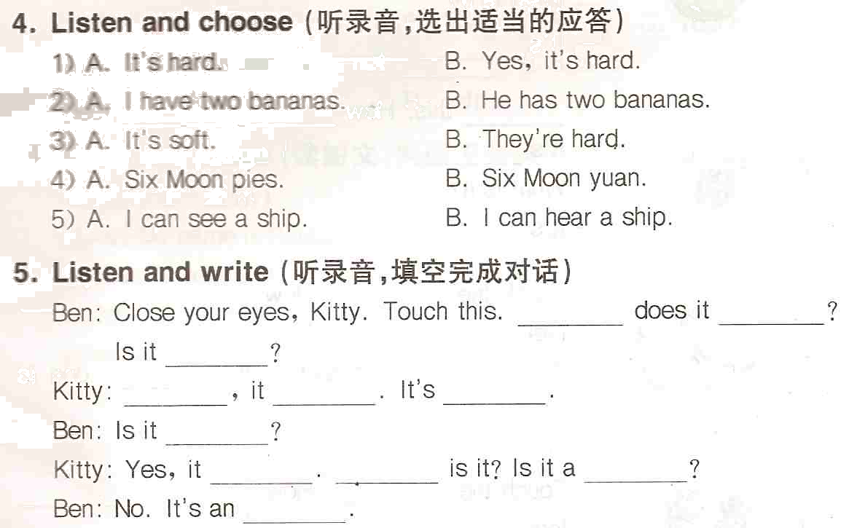

Reading and writing:
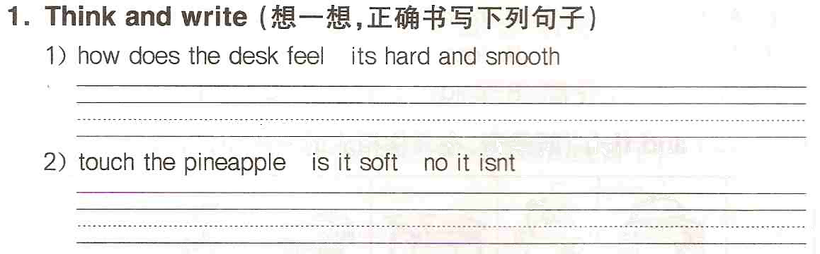
2. Look and write
1）写出下列名词的复数形式，没有复数的用“/”表示：
box __________ mouse _________ body __________
water ________ lime __________ monkey __________
jam __________ watch _________ child __________
2) 写出下列单词的反义词：
soft __________ smooth __________ hot __________
long __________ black __________ yes __________
old __________ big __________ open __________
3. Read and write（用所给单词的适当形式填空）
1) There are two __________ (circle) in the picture.
2) I can hear ______ (a) aeroplane.
3) Is that __________ (you) teacher? Yes.
4) Ben can read but he __________ (not) write.
5) This is __________ (insect). It _________ (have) six __________ (leg).
6) Listen to ____________ (teacher). She is singing.
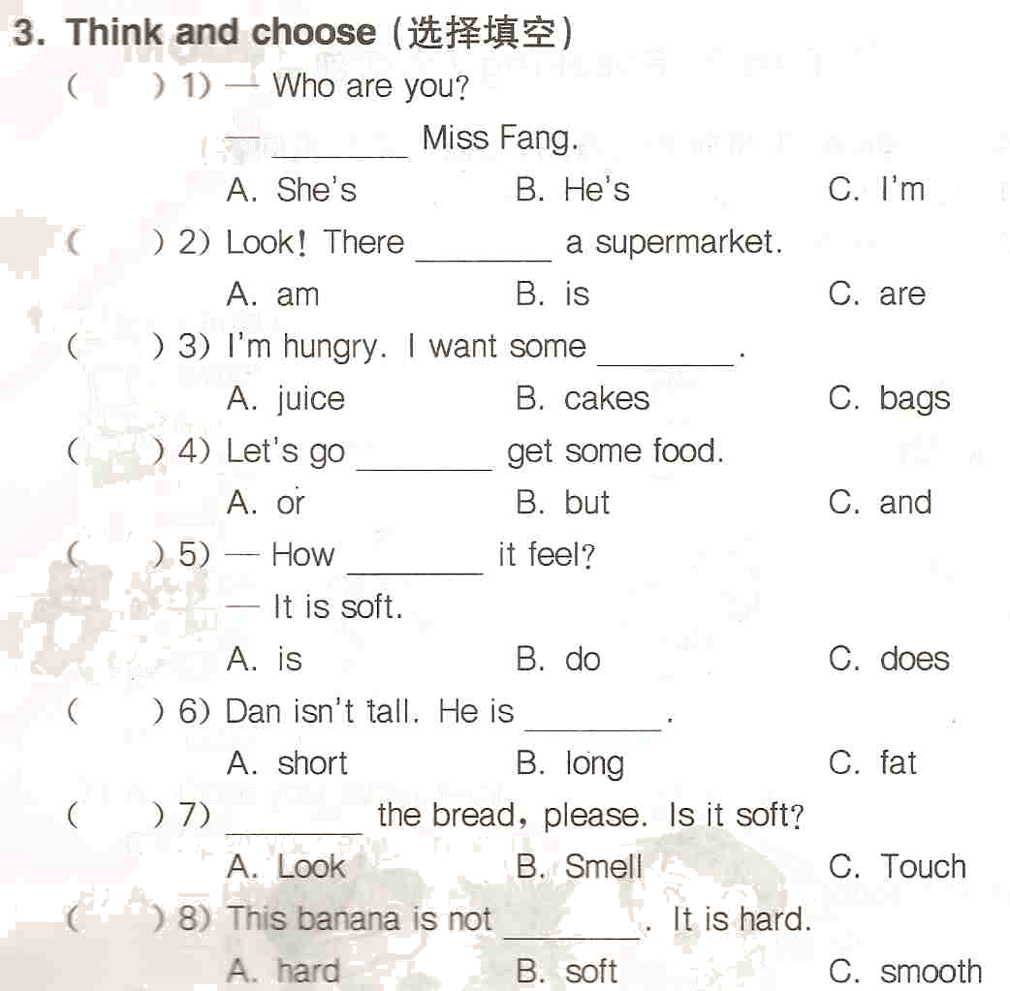
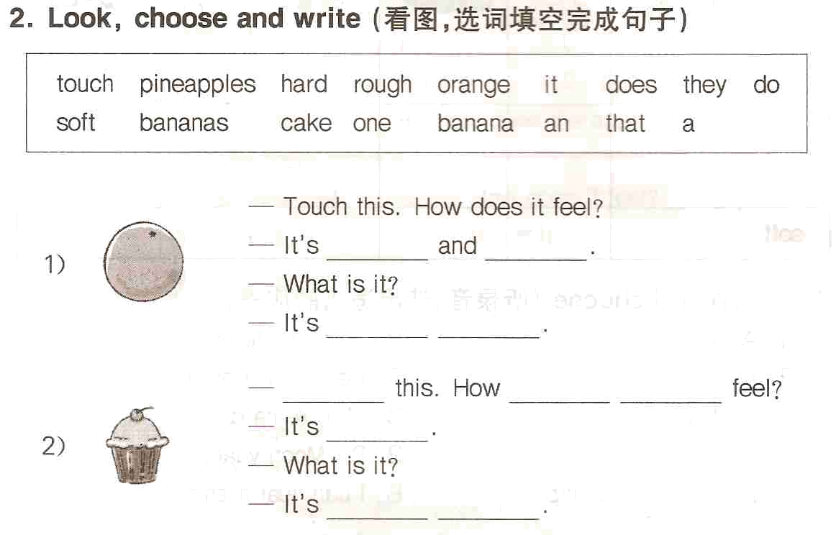
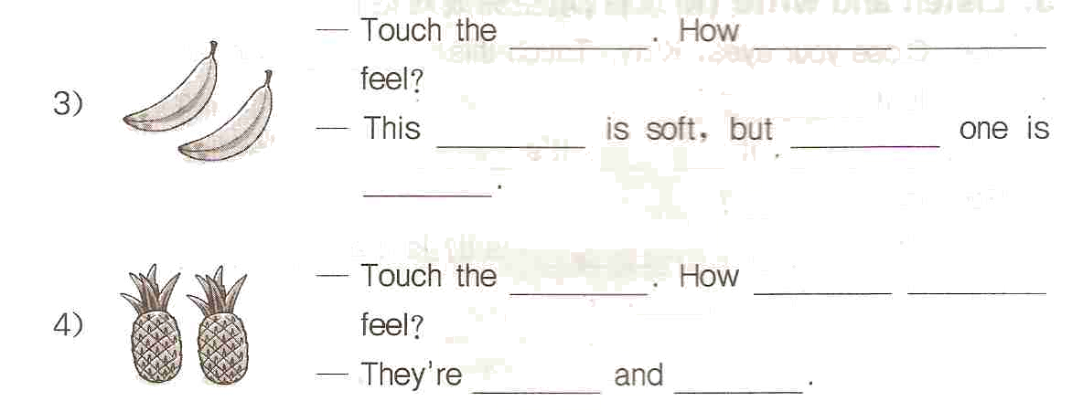
6. Change the sentences（按要求改写句子）
1) I can hear a train.（改为否定句）
______________________________________________________
2) The toy car is on the table.（改为一般疑问句）
______________________________________________________
3) The ship is white and blue.（对划线部分提问）
______________________________________________________
4) The pineapple is rough.（对划线部分提问）
______________________________________________________
5) The glasses are hard and smooth.（对划线部分提问）
______________________________________________________
7. Read and match（问答句配对）
( ) How do the balloons feel? | A. It is hard and rough.
( ) How does the pineapple feel? | B. It is hot.
( ) How is the dress? | C. They are smooth.
( ) Is the coffee hot or cold? | D. It is cold.
( ) How does the ice-cream feel? | E. It is nice.
( ) Is the desk smooth or rough? | F. It’s smooth.
