3B M2U1 周练卷4
Class_____ Name__________ No._____
Listening
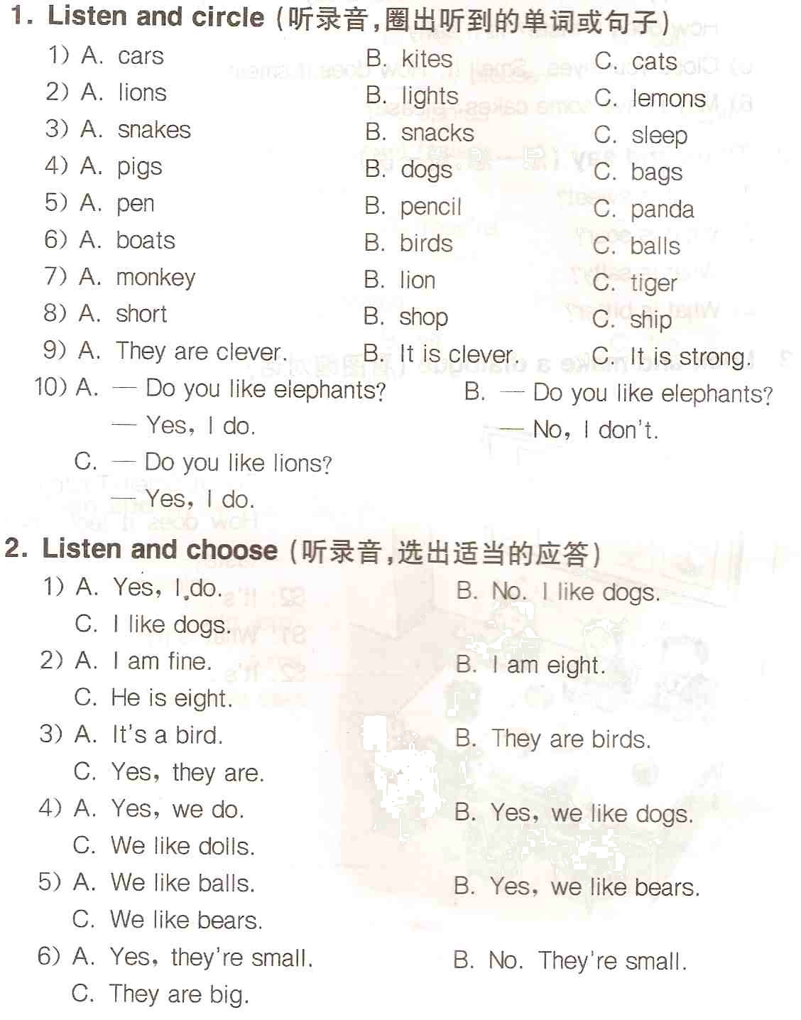
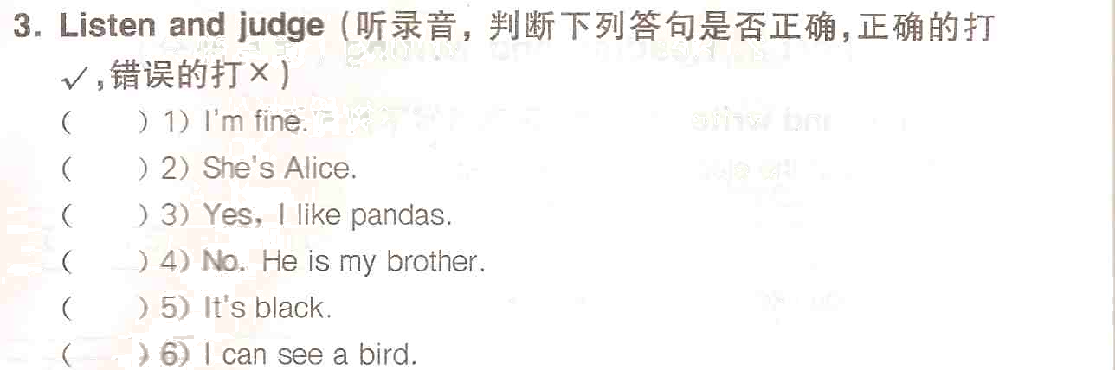

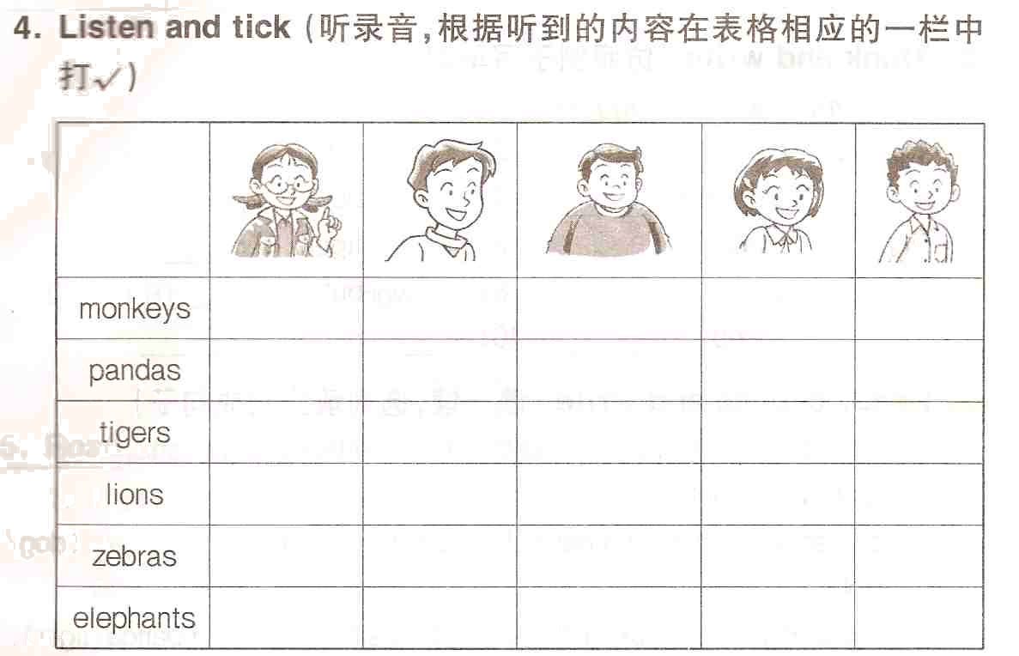
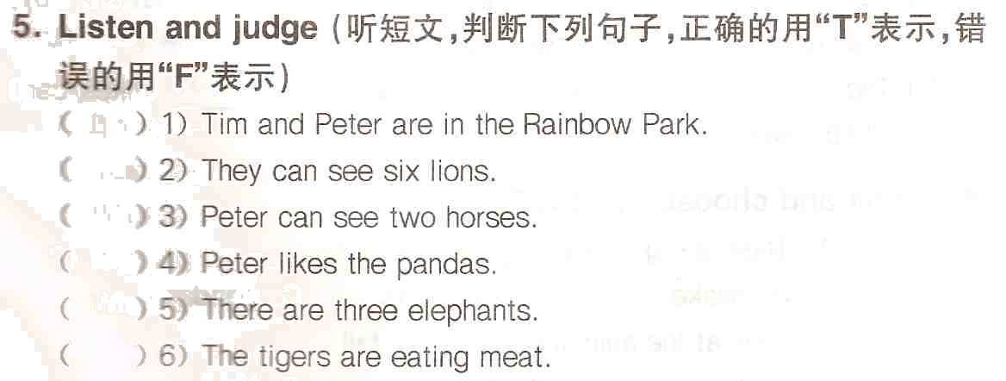
Reading and writing
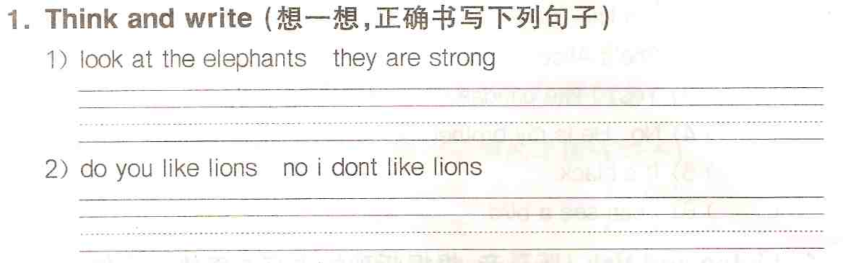
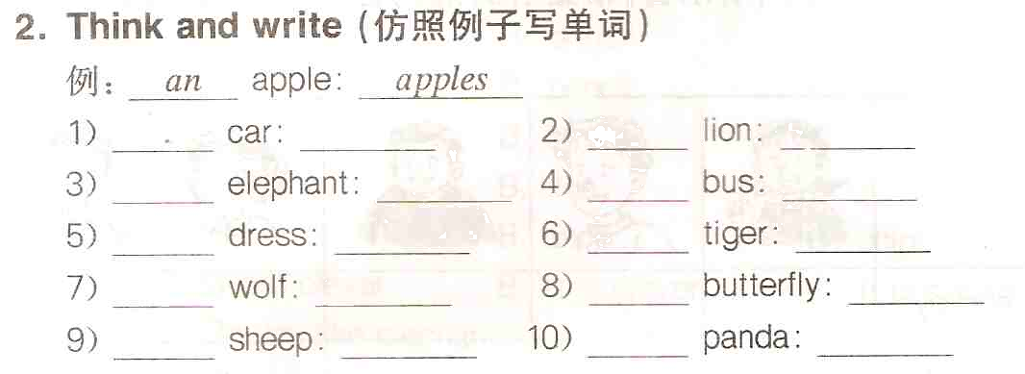
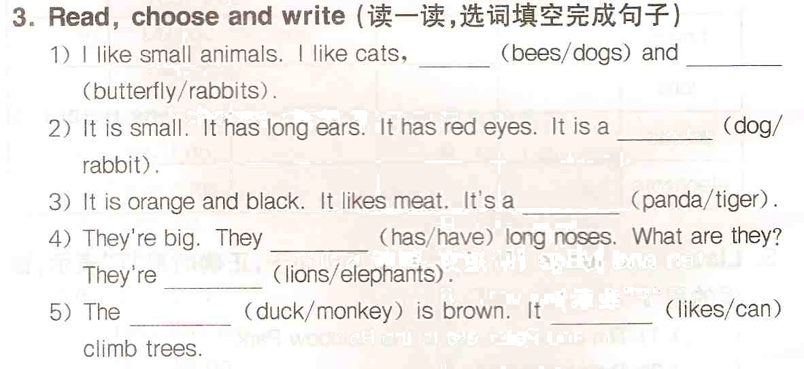
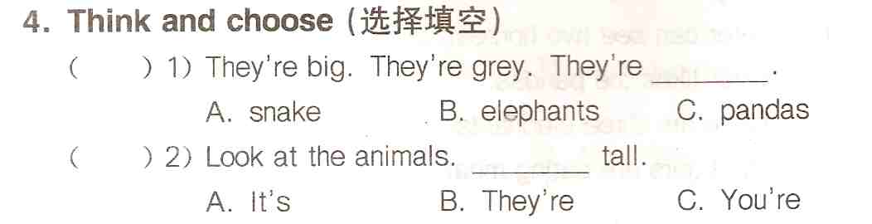
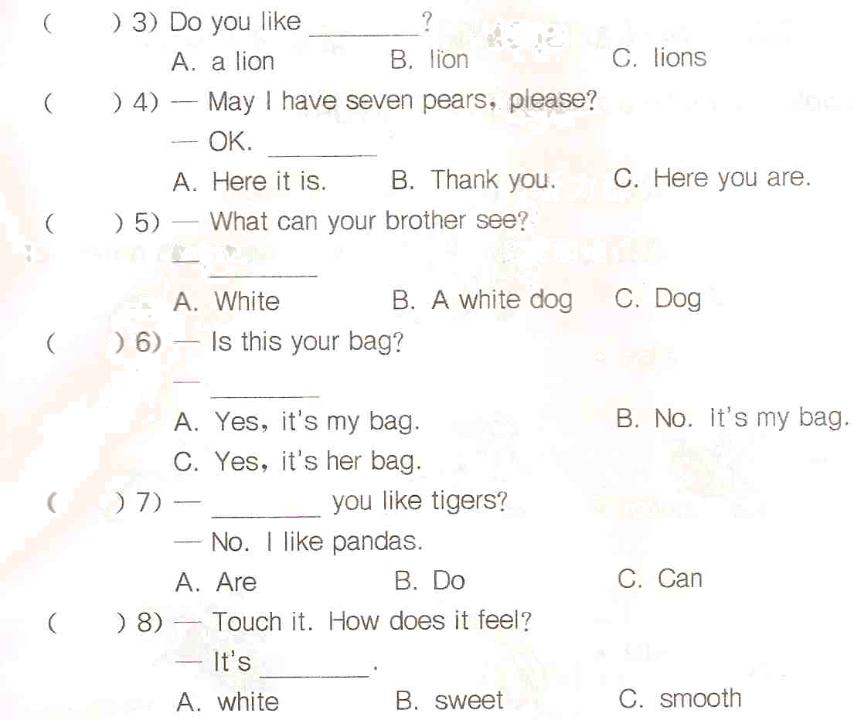
5. Think and write（用at, to, in, for, with填空）
1) Look _____ the picture. There is a beautiful park.
2) Listen _____ me, please.
3) Happy Birthday _____ you! Here’s a card _____ you.
4) I can smell _____ my nose.
5) Look _____ the mirror.
6. read and match（问答句配对）
( ) 1) How does it feel? | A. Very sour.
( ) 2) How does it smell? | B. Ten yuan.
( ) 3) How does it taste? | C. Very well, thanks.
( ) 4) How much is the ball? | D. Rough and hard.
( ) 5) How many pencils? | E. Eight pencils.
( ) 6) How are you? | F. Nice.
( ) 7) How old are you? | G. How do you do.
( ) 8) How do you do? | H. I’m ten.

7. Change the sentences（按要求改变句子）
1) This is a beautiful hat. （对划线部分提问）
________________________________________________________
2) l like tigers. （对划线部分提问）
________________________________________________________
3) The dog is clever. （改成复数句）
________________________________________________________
4) I like the pandas. （改成否定句）
________________________________________________________
5) l like elephants. （改成一般疑问句，并否定回答）
________________________________________________________
