3B M2U2 周连卷5
Class_____ Name__________ No._____
Listening:
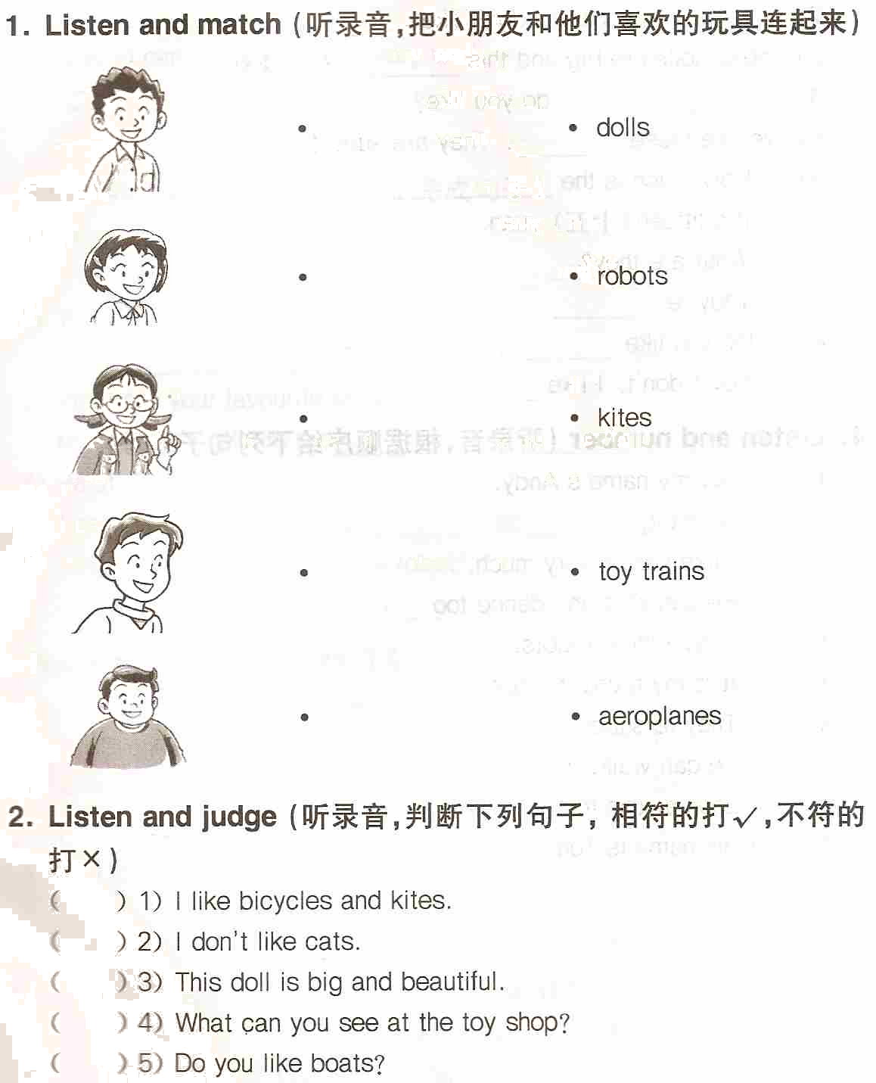
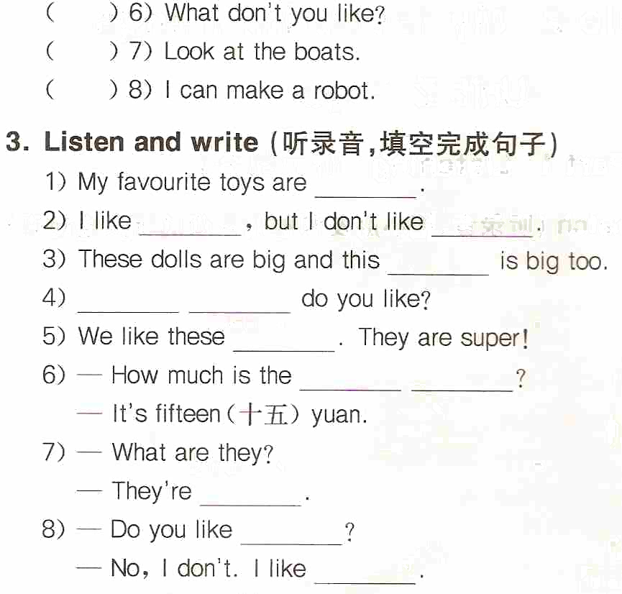
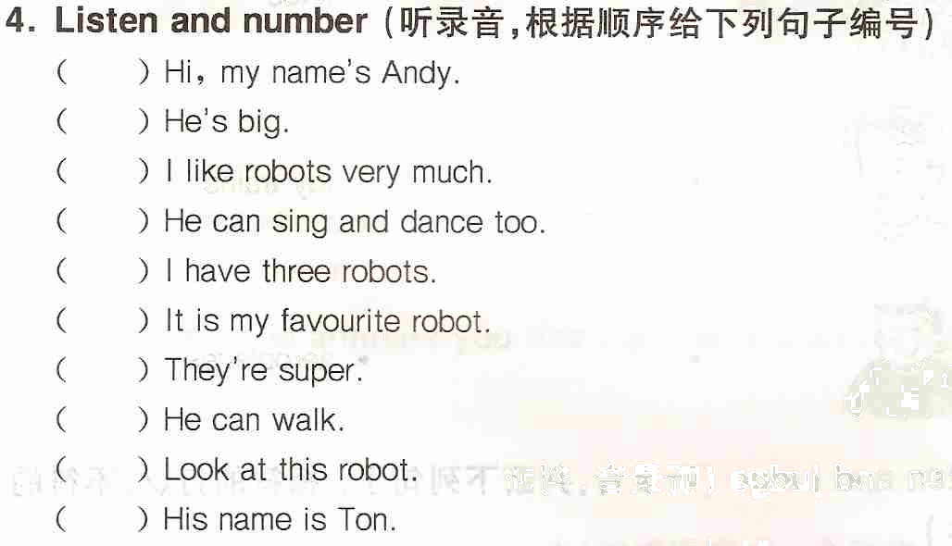
Reading and writing:
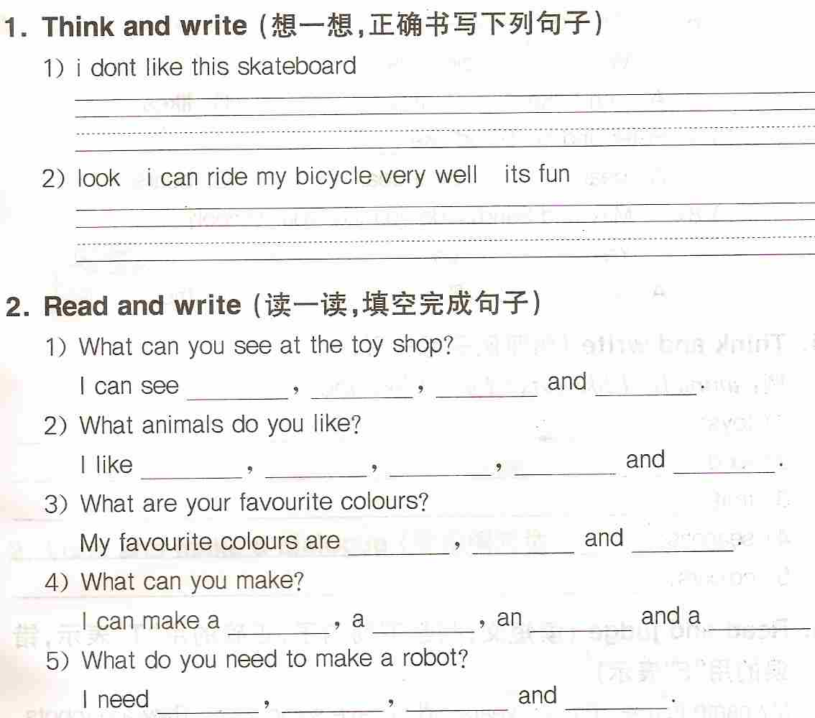
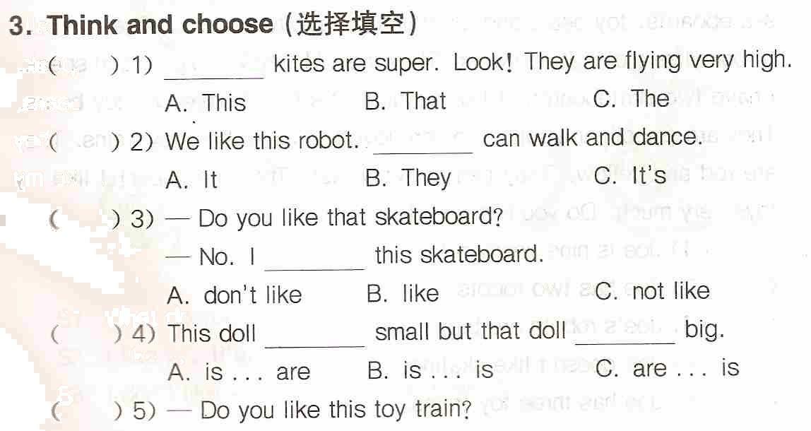
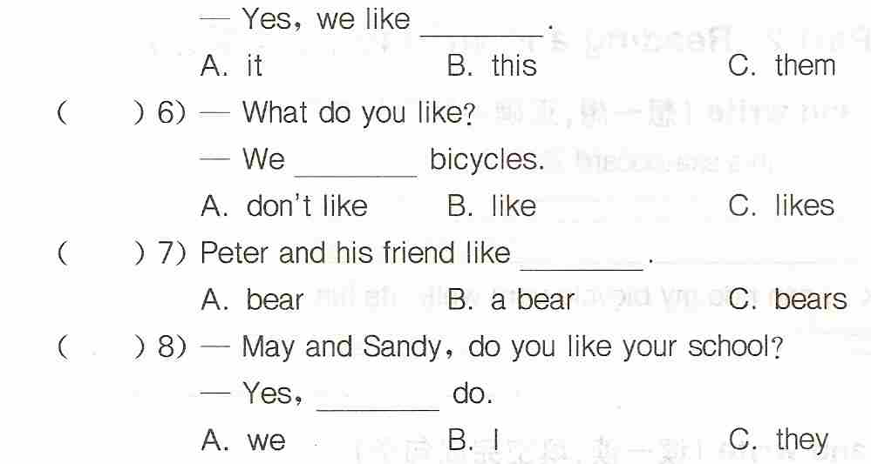
( ) 9) How many ________ ? Three.
A. boat B. boats C. a boat
( )10) What do you like? ________ like balls.
A. We B. You C. They
( )11) How ________ it feel?
A. does B. do C. is
( )12) I can see ________ aeroplane in the sky.
A. an B. a C. /
( )13) I’m hungry. I want some ________.
, A. Coke B. water C. cakes
( )14) Look at the robot. ________ can walk.
A. It B. He C. They
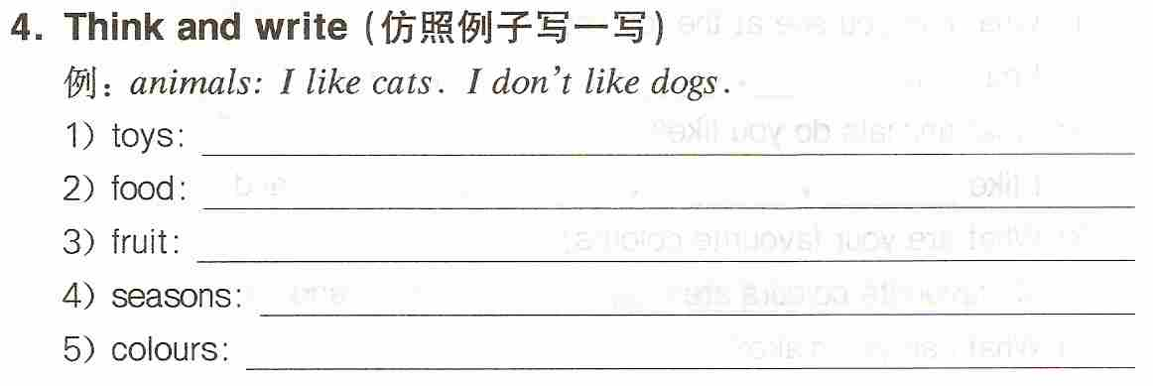
5. Change the sentences（按要求改写句子）
1. The train is big. （否定句）
__________________________________________________________
2. l like sweet biscuits. （否定句）
__________________________________________________________
3. l like the skateboard. （对划线部分提问）
__________________________________________________________
4. I can ride the bicycle very well. （一般疑问句，并肯定回答）
_________________________________ _______________________
5. We like bears. （一般疑问句，并否定回答）
_________________________________ _______________________
