3B M3U1 周练卷7
Class_____ Name__________ No._____
Listening:
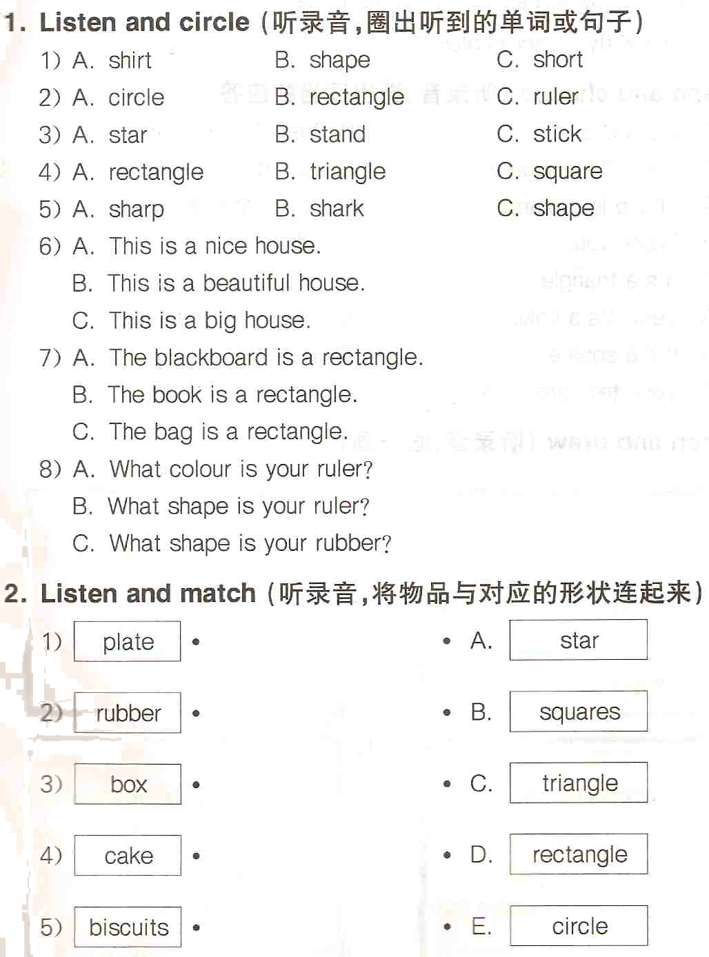
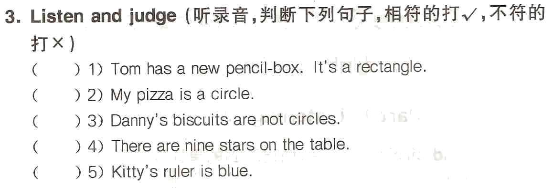

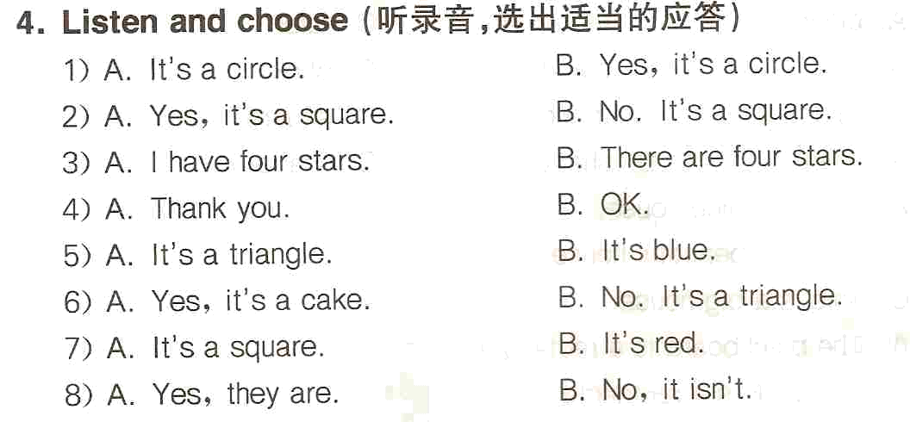
Reading and writing:
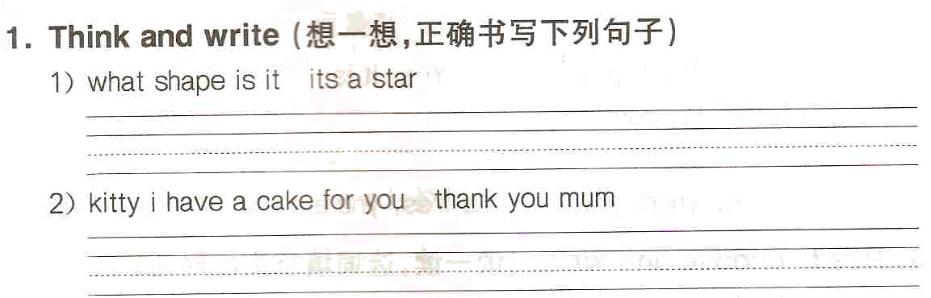
2. Fill in the blanks (用所给单词的正确形式填空)
1) This is ________ (he) mother. She likes ________ (house).
2) What colour ________ (be) the circles? ________ (it) are blue.
3) How many ________ (star) are there on the wall? One ________ (star)
4) There are ten ________ (box) in the hall.
5) What’s ________ (these)? It’s ______________ (aeroplane).
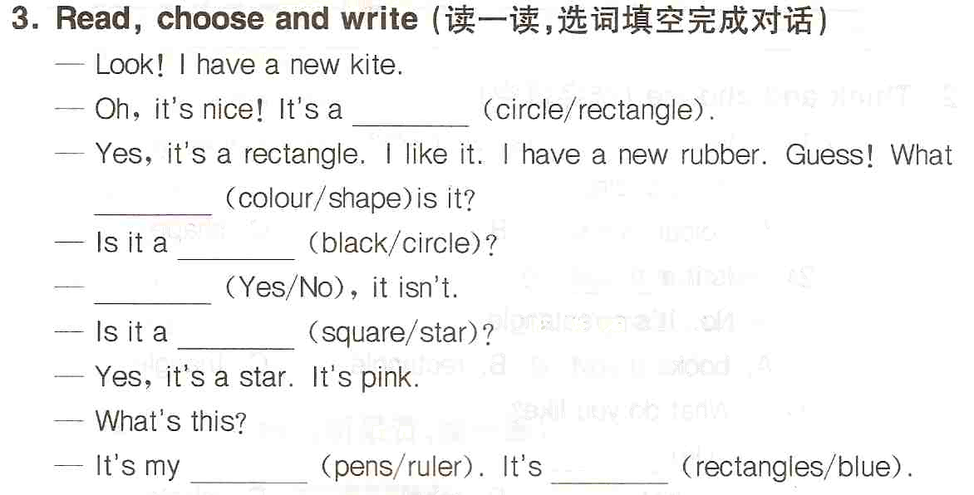

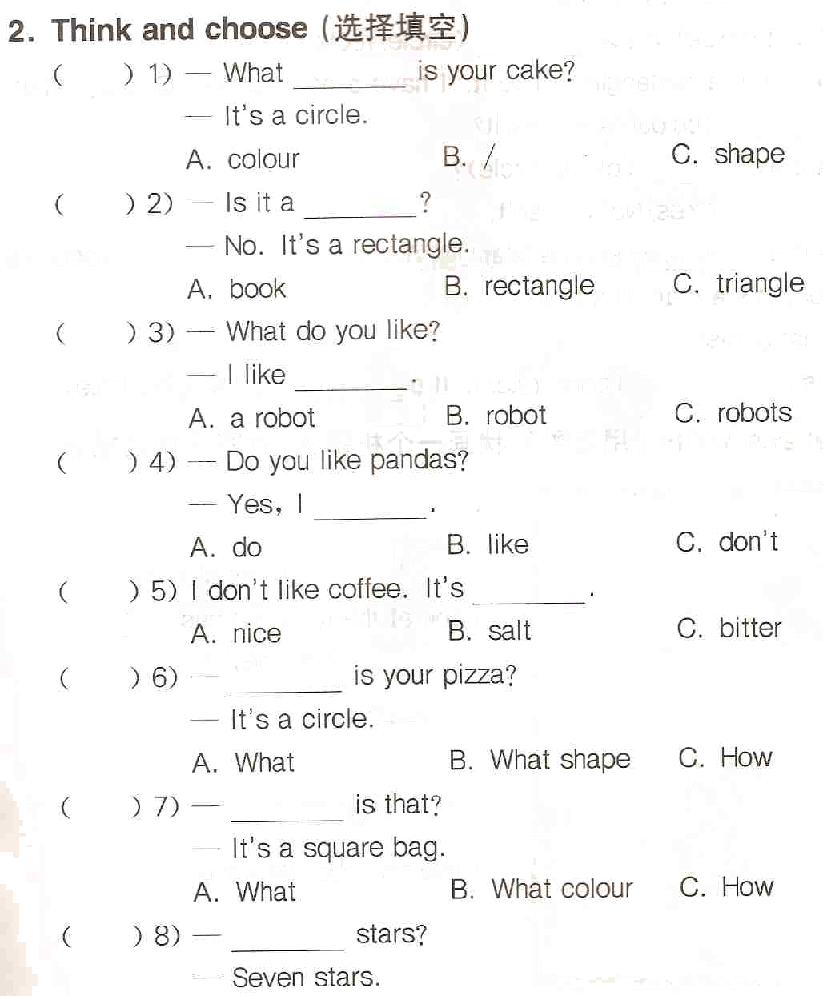
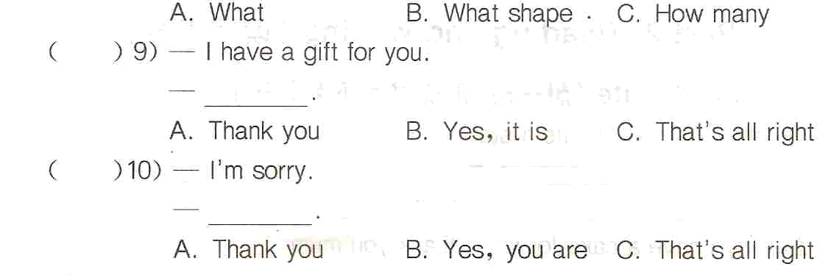
5. Rewrite the sentences (按要求改写句子)
1) There are four apples on the table. （一般疑问句）
_______________________________________________________
2) My brother can write. （一般疑问句）
_______________________________________________________
3) My friends like stars. （否定句）
_______________________________________________________
4) The biscuit is a star. （对划线部分提问）
_______________________________________________________
5) I’m very well today. （对划线部分提问）
_______________________________________________________

