3B M3U2 周练卷8
Class____ Name________ No.____
Listening
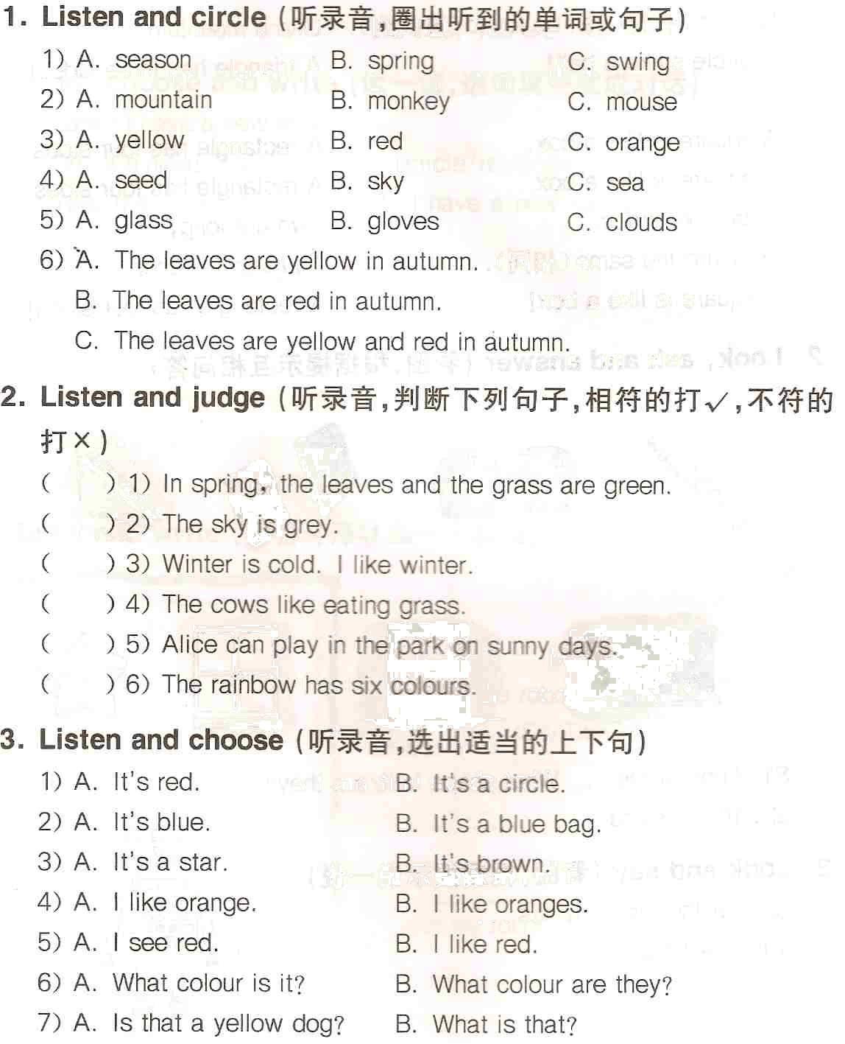
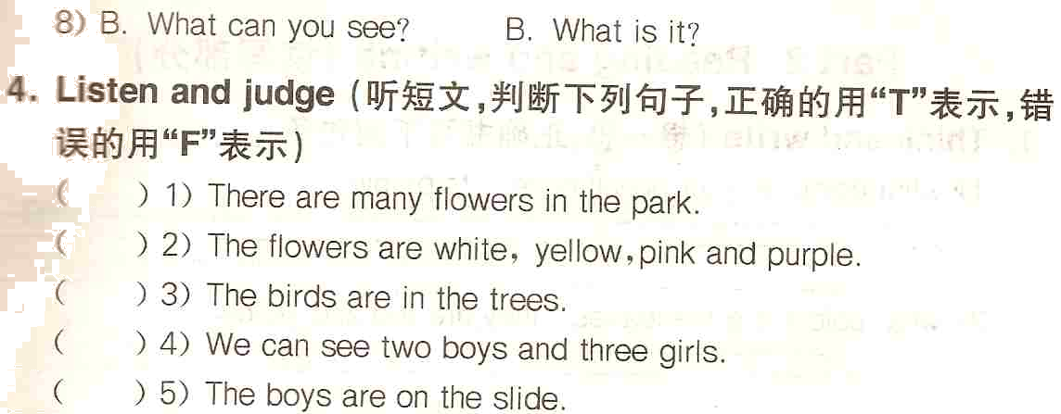

5. Listen and write（听录音，填空）
It is a hot ________ day. The ________ is blue. The ________ is red. The ________ are white. I can see the ________ in the sky. It is red, ________, yellow, green, blue, ________ and violet. The ________ is blue. The ________ are green. The ________ and the grass are green too. Look! There are many beautiful _______. They are yellow and ________.
Reading and writing
1. Think and write（正确抄写下列句子）
1) what colour is your pencil case its purple
____________________________________________________________
2) what colour are the leaves theyre red and yellow
____________________________________________________________
2. Read and write（写出两个与划线部分同类的单词）
1) I like to eat biscuits. __________ __________
2) We have got eight oranges. __________ __________
3) You can see white snow in winter. __________ __________
4) Our teacher can swim well. __________ __________
5) I like winter. __________ __________
