3B M3U3 周练卷9
Class____ Name________ No.____

Listening:
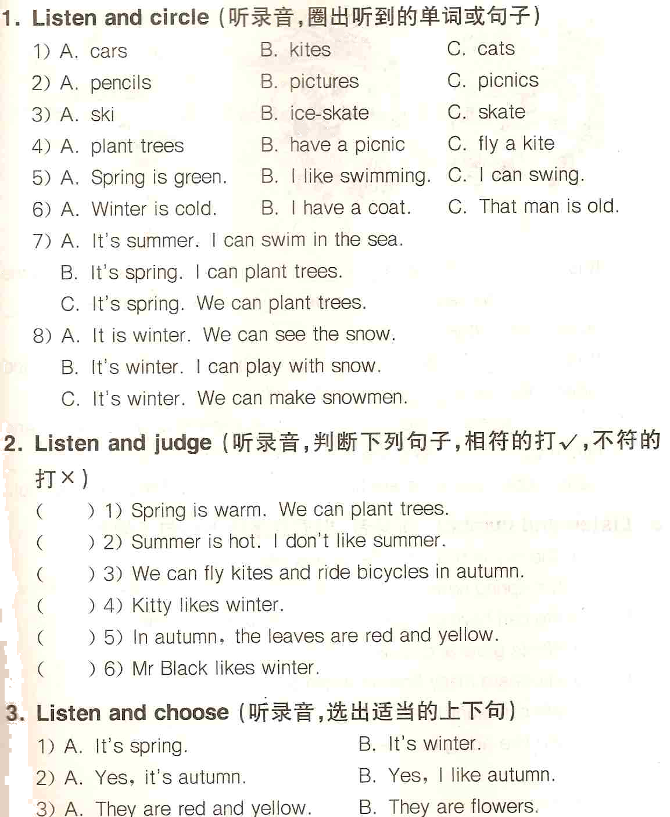
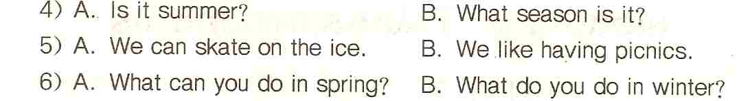

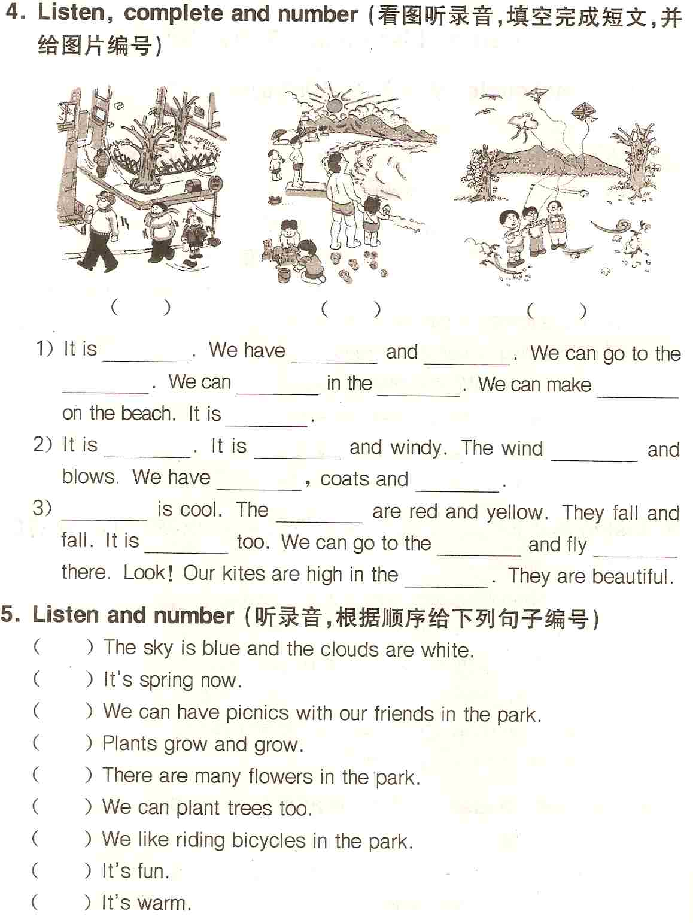
Reading and writing:
1. Think and write（想一想，正确书写下列句子）
1) in spring we can have picnics in the park
__________________________________________________________
2) what season is it its winter
__________________________________________________________

2. Read and write（按要求写单词）
I（同音词）________ fall（同类词）________
hot（反义词）________ leaf（复数）________
pair（同音词）________ glasses（单数）________
you（物主代词）________ autumn（同类词）________
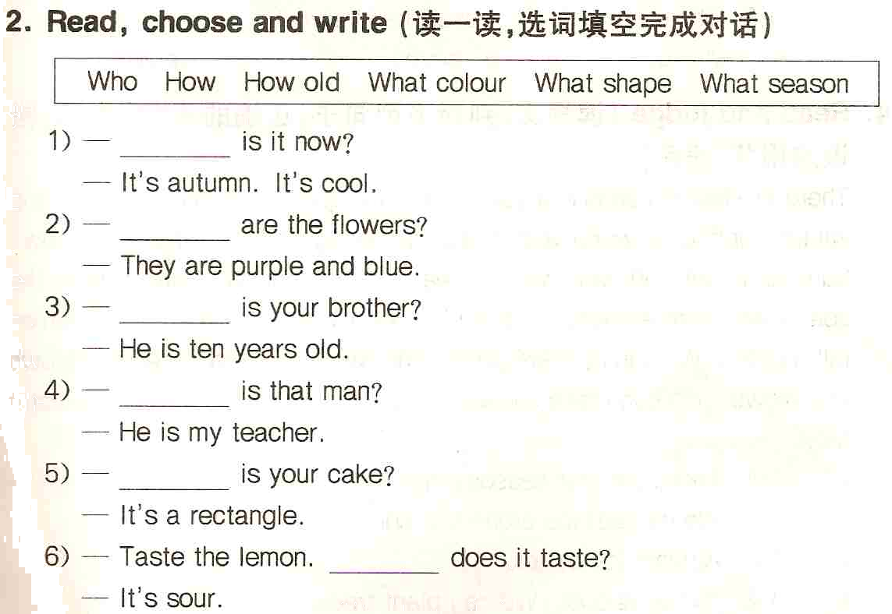
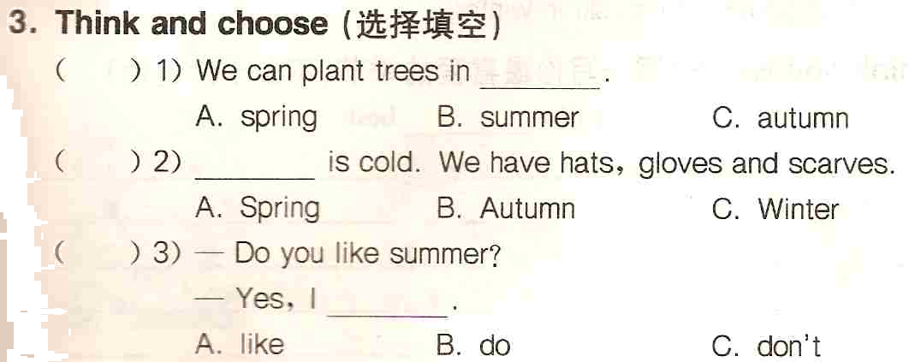
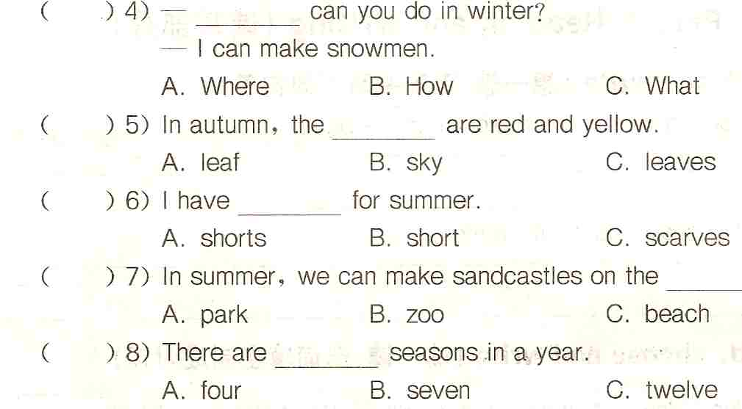
5. Rewrite the sentences（按要求改写句子）
1) The birds are in the tree. （用Where提问）
________________________________________________________
2) It is winter. （对划线部分提问）
________________________________________________________
3) I have some red flowers. （否定句）
________________________________________________________
4) Eddie can go to the beach. （否定句）
________________________________________________________
5) We can plant trees in spring. （一般疑问句）
________________________________________________________
6) I like eating ice-creams. （一般疑问句）
________________________________________________________

