3B M4U1 周练卷10
Class_____ Name__________ No._____
Listening:
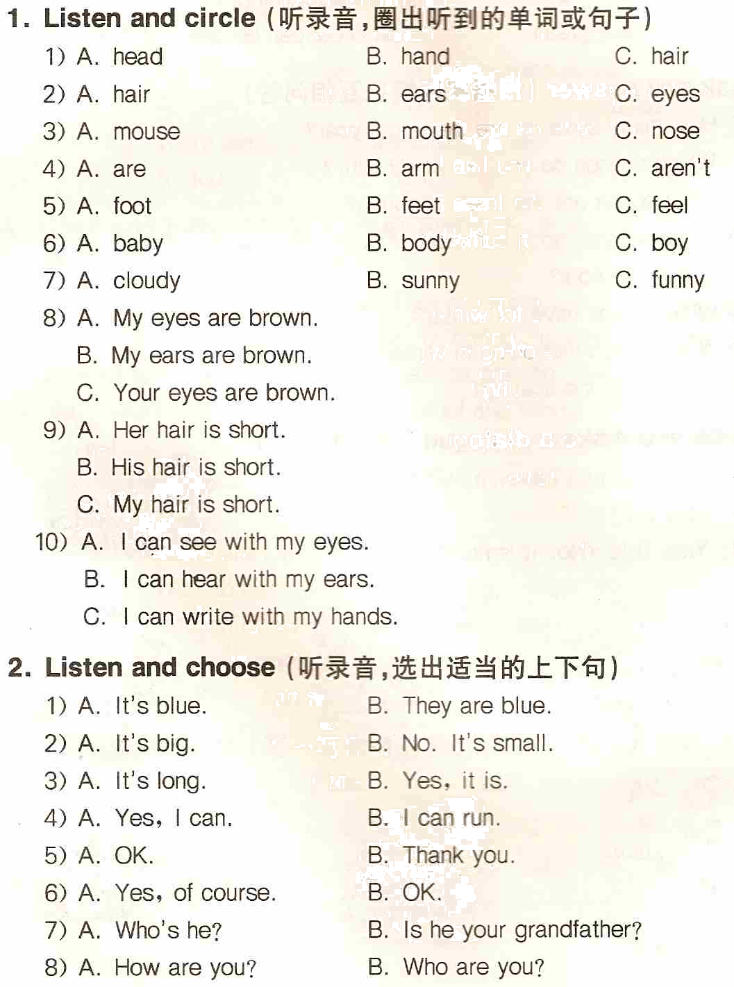
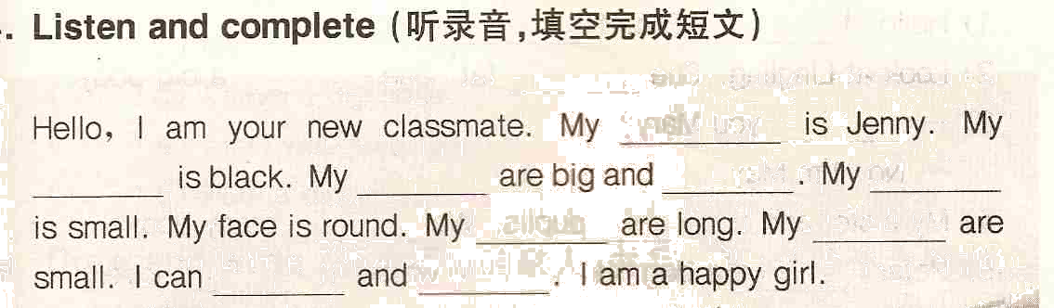
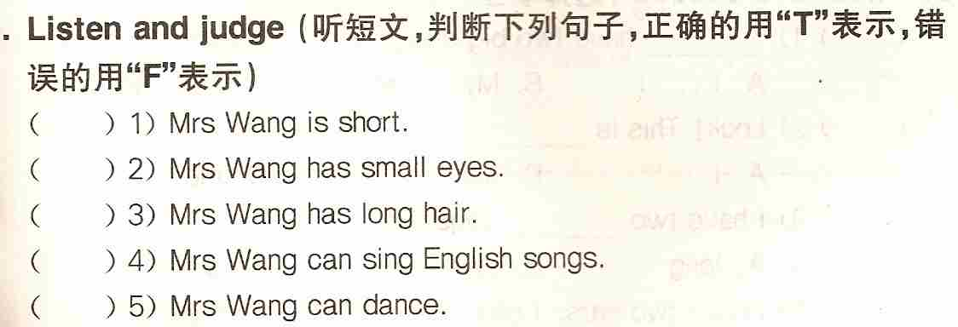

Reading and writing
1. Think and write（想一想，正确书写下列句子）
1) can you touch your arms alice yes of course
_____________________________________________________________
2) are your eyes brown no theyre blue
_____________________________________________________________
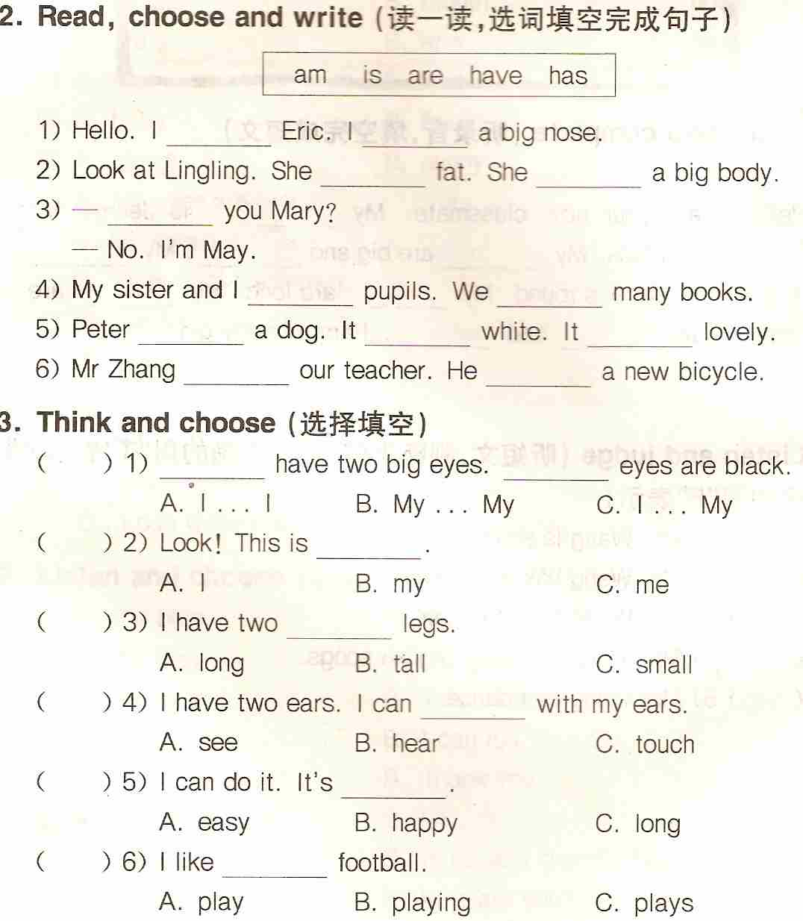
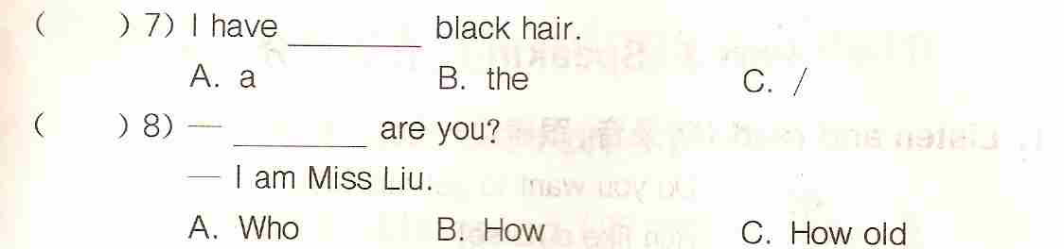
( ) 9) Your mother’s hair _____ long and brown.
A. is B. am C. are
( )10) My eyes _____ big. My head _____ small.
A. is…is B. is…are C. are… is
( )11) He’s not old. He’s _____.
A. new B. young C. tall
( )12) Clap your ________, please.
A. hands B. hand C. heads

4. Fill in the blanks（用所给单词的适当形式填空）
1) Can you draw __________ (your)? Yes, I can draw __________ (my).
2) His ________ (foot) are big. His ________ (body) is fat.
3) This is ________ (I) sister. ________ (she) is Mary.
4) My sister ________ (have) a new friend. ________ (he) name is Ben.
5) I can ________ (ski). And I like ______________ (ice-skate).

5. Ask and answer（根据实际情况或提示回答问题）
1) What colour is your hair?
___________________________________
2) Can you draw yourself?
____________________________________
3) How is your mouth?
____________________________________
4) What do you have?（两条长腿）
____________________________________
5) What are those?（手）
_____________________________________

