3B M4U2 周练卷11
Class____ Name________ No.____
Listening:
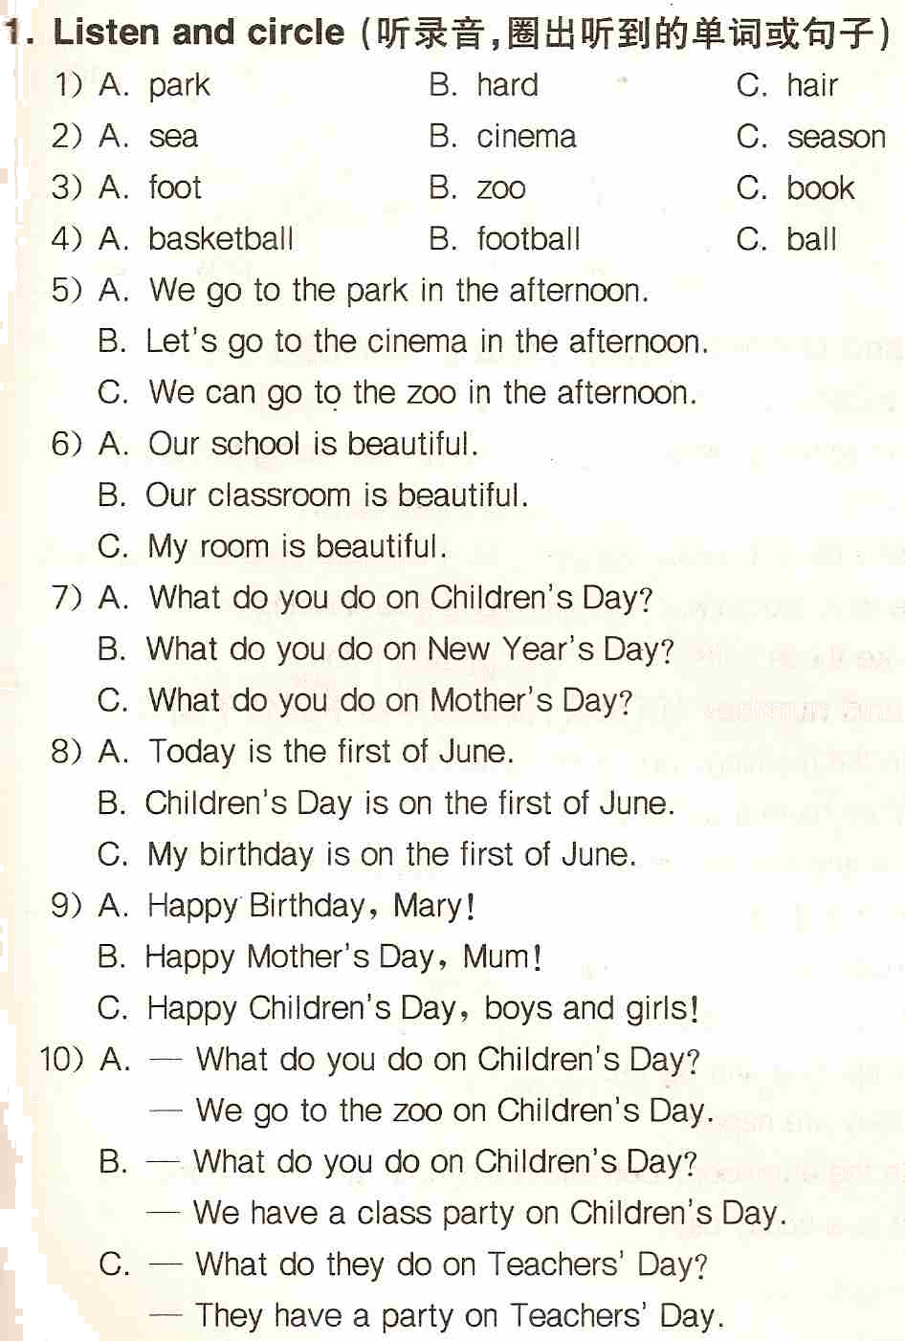
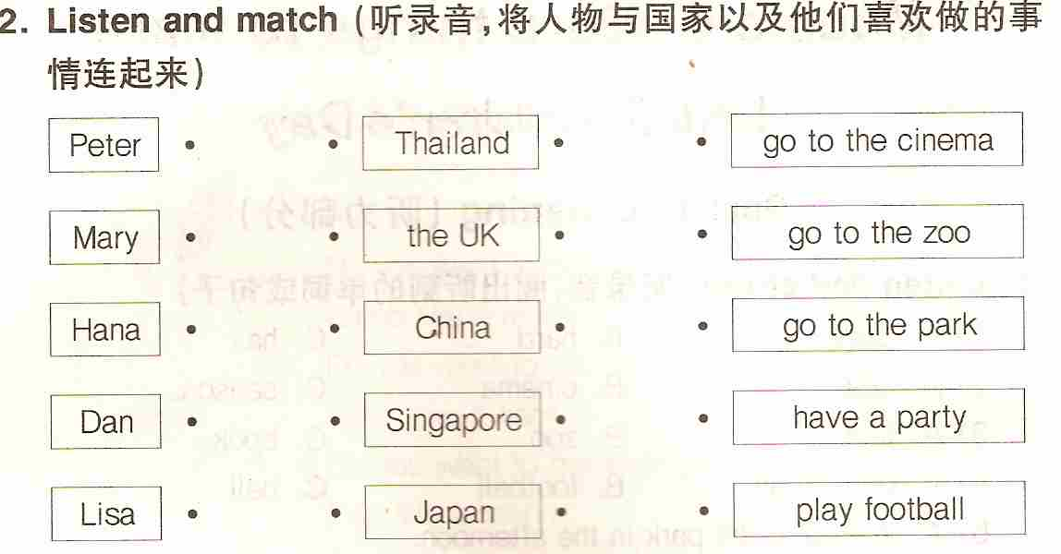
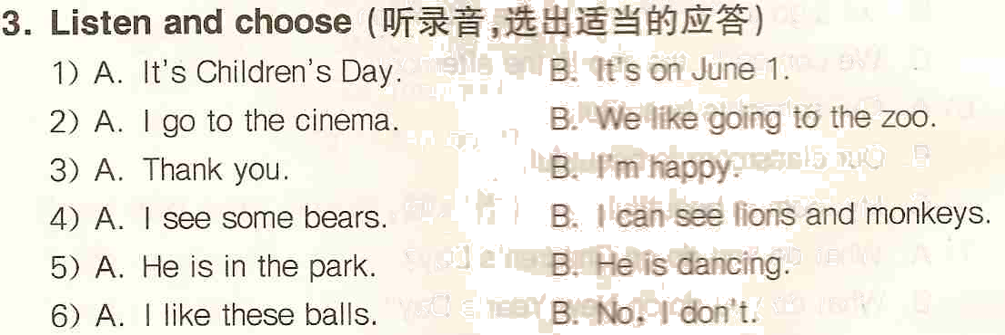
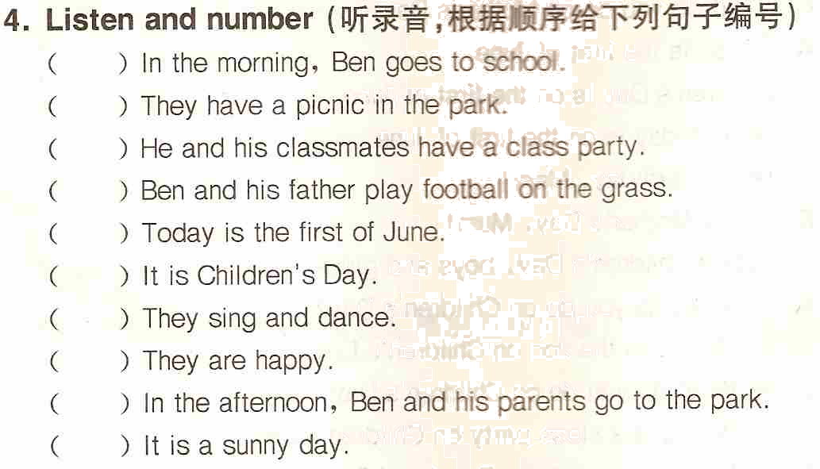
Reading and writing:
1. Think and write（想一想，正确抄写下列句子）
1) alice and mary lets sing a song together
____________________________________________________________
2) what do you do on childrens day I go to the park with my parents
____________________________________________________________
2. Write the words（按要求写单词）
1) child（复数）____________ 2) one（序数词）____________
3) have（动名词）__________ 4) skate（动名词）__________
5) fun（形容词）___________ 6) photo（同义词）___________
7) I（物主代词）___________ 8) do not（缩写）____________
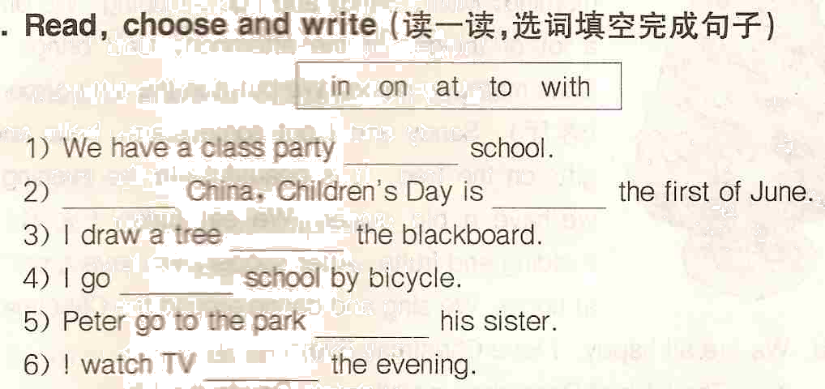
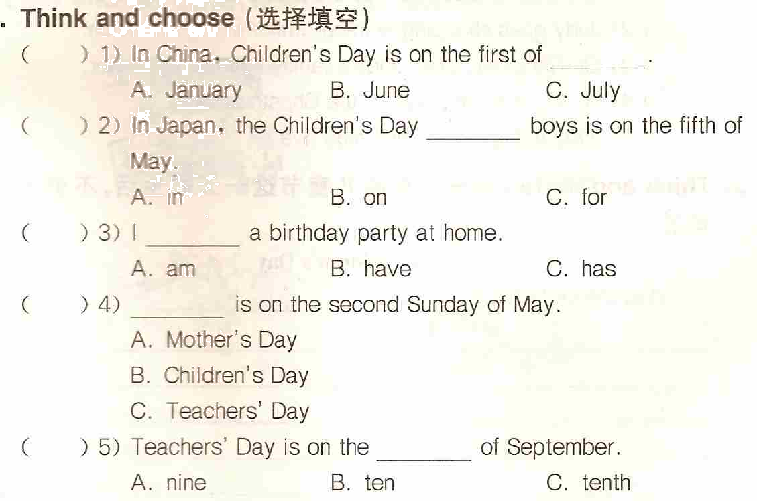
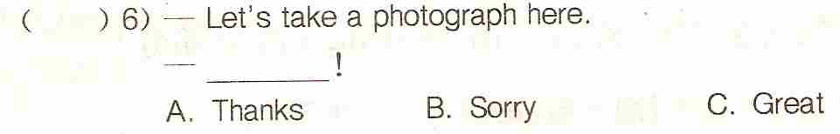
( ) 7) Everyone is having ________.
A. a fun B. funny C. fun
( ) 8) What ______ you ______ on Saturday? I skate.
A. do, do B. can, do C. do, can
( ) 9) I want to see films（电影）. Let’s go to the ________.
A. park B. zoo C. cinema
( ) 10) Our ______ is beautiful today.
A. class B. classroom C. classrooms
( ) 11) Many children ______ in the park.
A. is B. are C. am
( )12) Let’s ______a song together.
A. singing B. sing C. is singing

5. Rewrite the sentences（按要求改写句子）
1) I am very well today.（对划线部分提问）
__________________________________________________________
2) Eddi can climb the tree.（否定句）
__________________________________________________________
3) It’s a cirecle. （对划线部分提问）
__________________________________________________________
4) The leaves are green. （对划线部分提问）
__________________________________________________________
5） Look at the picture.（否定句）
__________________________________________________________
6） We have a class party on Children’s Day. （对划线部分提问）
__________________________________________________________
7) The little girl is in the cinama. （对划线部分提问）
__________________________________________________________
