3B M4U3 周练卷12
Class____ Name________No.____
Listening:
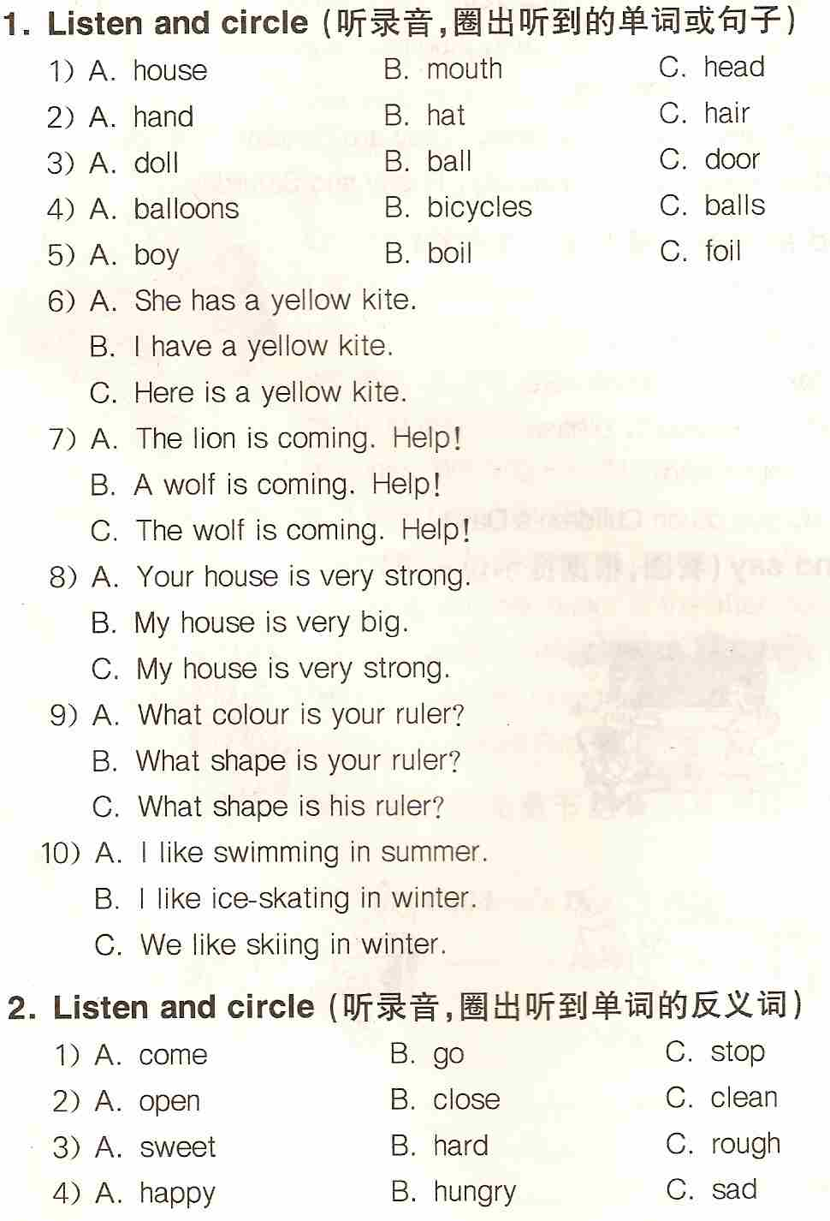
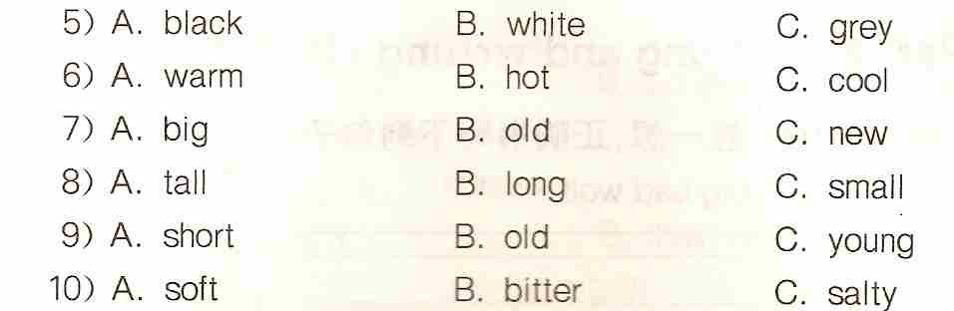
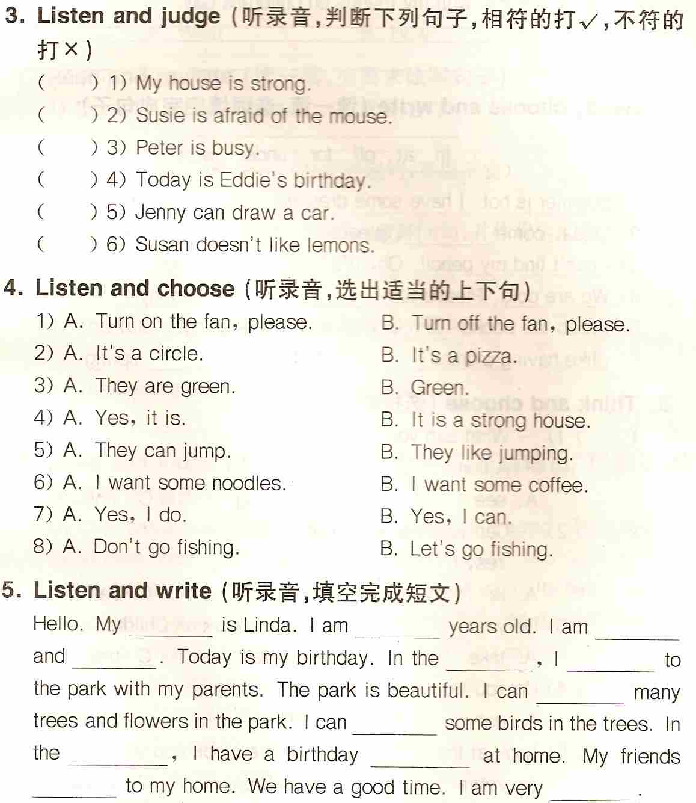

Reading and writing:
1. Think and write（想一想，正确抄写下列句子）
1) you cant come in big bad worf
___________________________________________________________
2) i go to the zoo with my friends on childrens day
___________________________________________________________

2. Write the words（按要求写单词）
1) sky（同类词）______________ 2) blue（同类词）______________
3) hot（反义词）______________ 4) warm（反义词）_____________
5) hair（复数）_______________ 6) foot（复数）_______________
