4A Module 1 Test
Class ________ Name _________ Mark __________
Part One Listening 40%
I. Listen and choose (听录音，选出听到的单词) 8%
( ) 1. A. swim B. swing C. sweet
( ) 2. A. cook B. cake C. Coke
( ) 3. A. thirteen B. thirsty C. thirty
( ) 4. A. sad B. bad C. dad
( ) 5. A. paint B. play C. plant
( ) 6. A. back B. black C. block
( ) 7. A. twelve B. eleven C. seven
( ) 8. A. he’s B. she’s C. his

II. Listen and choose the sentences (选出你听到的句子) 10%
( ) 1. A. Mike’s brother is thirteen years old.
B. Mike’s sister is thirteen years old.
C. Mary’s sister is thirteen years old.
( ) 2. A. Peter can swim, but he can’t jump.
B. Peter can swim, but he can’t swim.
C. Peter can jump. He can swim,too.
( ) 3. A. Have some bread, please.
B. Have some cakes, please.
C. Have some ice cream, please.
( ) 4. A. The little dog is sad. B. The little dog is happy.
C. The little dog is hungry.
( ) 5. A. Can you draw a tiger? B. Can you draw a panda?
C. Can you paint a panda?

III. Listen and choose the best answer (选择正确的应答) 10%
( ) 1. A. She is thirteen. B. He is thirteen. C. She is fifteen.
( ) 2. A. Yes, it can swim. B. No, it can swim. C. It can swim
( ) 3. A. Have some cakes. B. Have some juice.
C. Have some milk.
( ) 4. A. He is happy. B. She is happy. C. It is happy.
( ) 5. A. I am hungry. B. I am fine. C. I like playing.

IV. Listen and write (听录音，填入所缺单词) 10%
Mum: How do you ________, Ben and Kitty?
Ben & Kitty: We’re __________.
Mum: Are you _________?
Ben & Kitty: Yes, we are.
Mum: Have some _________ then.
Ben & Kitty: Thank you, mum. We both want some _________ too.
Mum: OK. Here you are.

V. Listen and write the sentences (听写句子) 12%
1. _____________________________________________
2. _____________________________________________

Part Two Writing 60%
I. Write the sentences correctly (正确书写下列句子) 8%
1. this is my classmate her name is kitty
________________________________________________
2. how does danny feel he’s very thirsty
________________________________________________
II. Look and write (看图，写出正确的单词) 12%
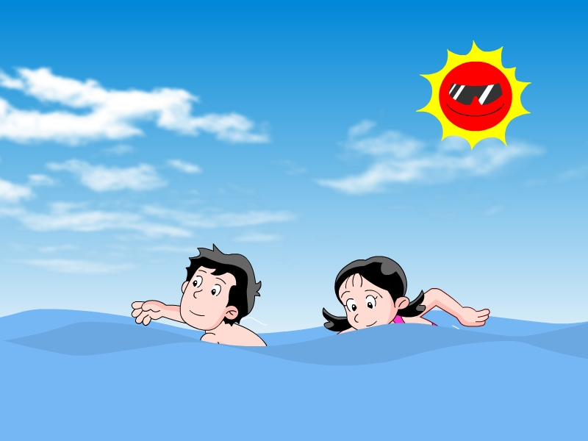
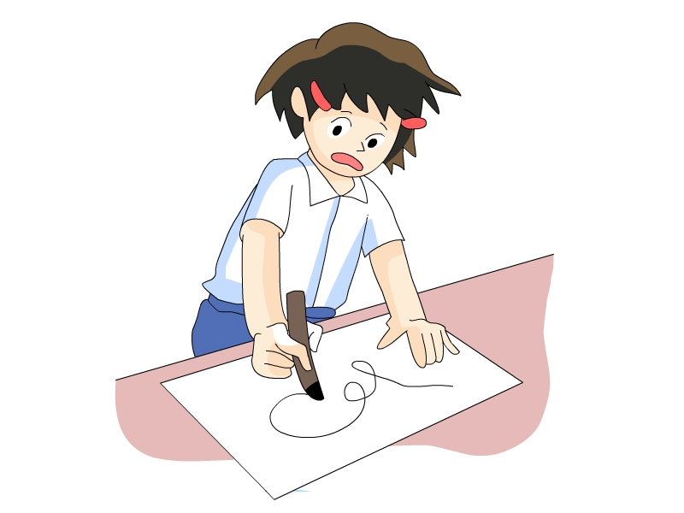
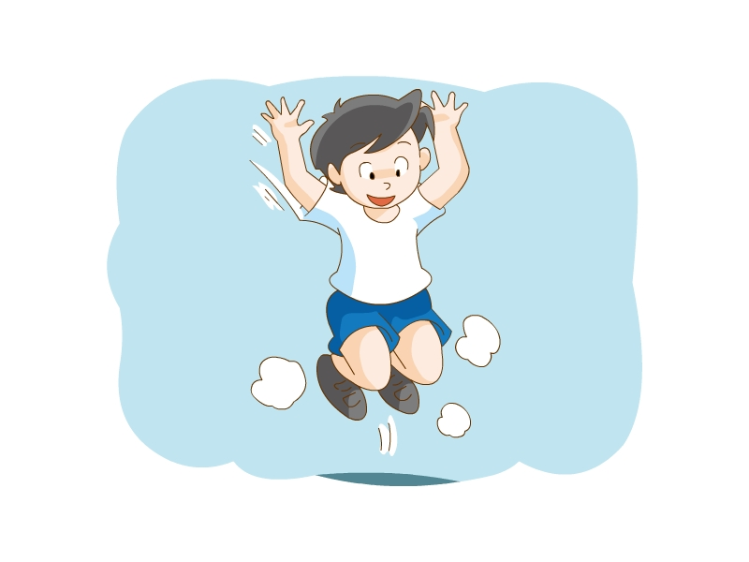
1. 2. 3.

___________ ___________ __________

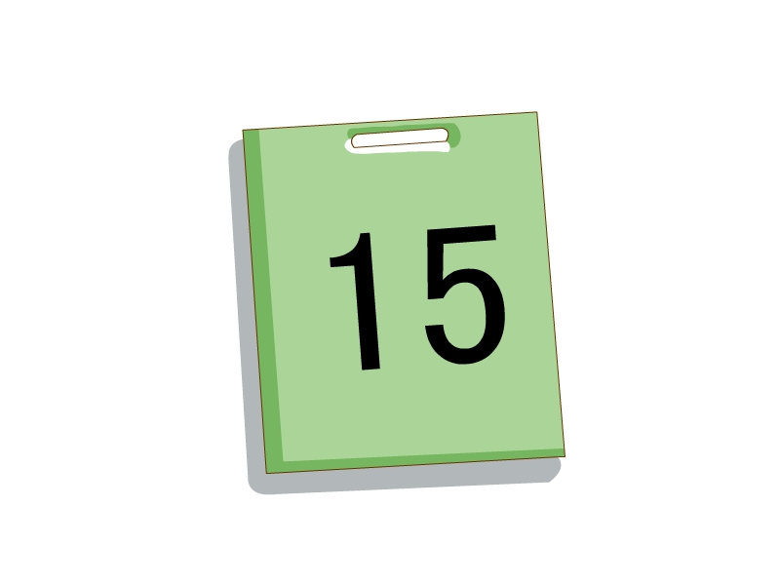
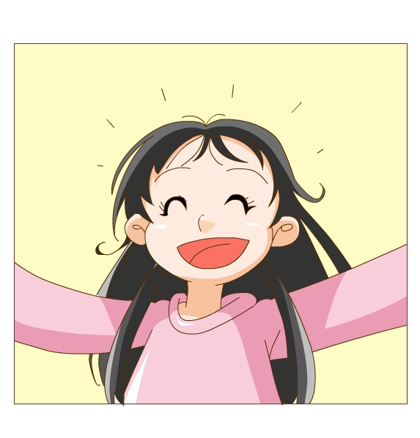
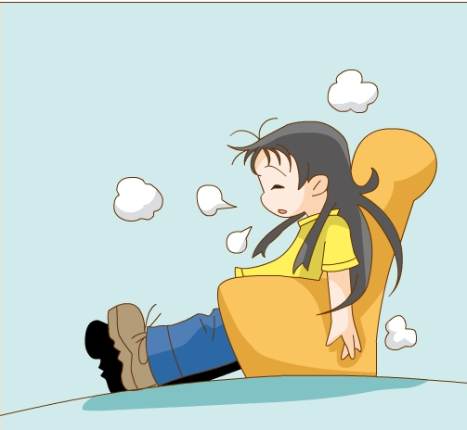
4. 5. 6.

____________ ___________ ___________

III. Read and complete (选词填空，完成句子，每个限用一次) 8%
my its her his we

- This is my brother. ________ name is John.
- Kitty and I are classmate. ________ are good students.
- This is _______ dog. ________ name is Sam.
- My little sister is five years old. ________ eyes are very big.

IV. Choose (选择题) 10%
( ) 1. I ________ play football.
A. am B. have C. have
( ) 2. How ________ your classmate feel?
A. does B. are C. do
( ) 3. Lily can swim, ________ she can’t dive.
A. and B. but C. too
( ) 4. I am ________. Come here and sit down, please.
A. happy B. hungry C. tired
( ) 5. Kitty, can your sister run fast? ______________.
- Yes, I can. B. Yes, she can. C. No, he can’t.

V. Rewrite the sentences (按要求改写句子) 10%
1. Her brother can draw a picture. (否定句)
____________________________________________
2. Supergirl can swim very well. (一般疑问句)
____________________________________________
3. Peter can read a book. (划线部分提问)
_____________________________________________
4. Eddie is hungry. (划线部分提问)
______________________________________________
5. There is a mouse in the cage. (改为复数句)
There ________ some ________ in the cage.

VI. Read and judge (阅读短文，判断短文，用T或F表示) 5%
Hi. I’m Mary. I’m a student of Grade Four. I like drawing. Look at this picture. Can you see two students in the playground? They’re my new classmates. The tall boy is running fast. His name’s Ben. He can swim well. But he can’t dance. That girl is skipping a rope. She’s Sue. Her hair is short. Her eyes are big. She can’t swim. But she can dance, draw and cook. Ben, Sue and I are good friends. I like them.
( ) 1. Ben and Sue aren’t students of Grade Four.
( ) 2. Ben is short. He can run fast.
( ) 3. Ben can’t dance. But he can swim very well.
( ) 4. Sue has short hair and big ears.
( ) 5. May, Ben and Sue are in the playground.
VII. Writing (写一写你的好朋友，可以使用老师给你的一些提示句子) 7%
His/Her name is … His/Her student number is …
He’s/ She’s… He/She can…
He/She can…but he/she can’t… He/She likes…
____________________
____________________________________________________________________________________________________________________________________________________________________________________________________________________
_____________________________________________________
听力内容
I. Listen and choose (听录音，选出听到的单词) 8%
1. The monkey can swing in the tree.
2. Here’s a Coke for you.
3. My student number is thirteen.
4. Peter isn’t sad.
5. Thant plant is big.
6. My eyes are black.
7. Is your sister twelve?
8. His bicycle is new.

II. Listen and choose the sentences (选出你听到的句子) 10%
1. Mike’s sister is thirteen years old.
2. Peter can jump. He can swim,too.
3. Have some cakes, please.
4. The little dog is sad.
5. Can you paint a panda?

III. Listen and choose the best answer (选择正确的应答) 10%
- How old is your sister?
- What can the fish do?
- I am hungry, Mum.
- How does your brother feel?
- What do you like doing?

IV. Listen and write (听录音，填入所缺单词) 10%
Mum: How do you feel, Ben and Kitty?
Ben & Kitty: We’re tired.
Mum: Are you thirsty?
Ben & Kitty: Yes, we are.
Mum: Have some water then.
Ben & Kitty: Thank you, mum. We both want some biscuits too.
Mum: OK. Here you are.

V. Listen and write the sentences (听写句子) 12%
1. Can Super dog fly? Yes, he can.
2. I like swimming very much.

