4B Module2 单元练习卷
班级 学号 姓名 得分
Part 1 Listening听力部分
ⅠListen and choose (听录音，选出听到的内容)10%
( ) 1. A. basketball B. badminton C. volleyball
( ) 2. A. bone B. ball C. blue
( ) 3. A. mouth B. mice C. mouse
( ) 4. A. make a model ship B. make a model car
C. make a model plane
( ) 5. A. tell us a fairy tale B. tell us a story
C. tell me a fairy tale
( ) 6. A. her favourite food B. his favourite sport
C. her favourite drink
( ) 7. A. The swimming cap cannot be too big or too small.
B. The swimsuit cannot be too big or too small.
C. The swimming goggles cannot be too big or too small.
( ) 8. A. The mouse goes back to his hole.
B. The mouse climbs onto a door.
C. The mouse jump off the door.
( ) 9. A. I usually watch TV with my parents at night.
B. I usually read storybooks before bedtime.
C. I usually do my homework at night.
( ) 10. A. Where’s Paul? B. Who’s Paul? C. How’s Paul?

ⅡListen and choose (选出听到的单词的反义词)5%
( ) 1. A. little B. big C. large
( ) 2. A. sad B. hungry C. full
( ) 3. A. beside B. between C. behind
( ) 4. A. thick B. thin C. short
( ) 5. A. full B. thirsty C. tired

ⅢListen and choose the best answer(听录音，选择正确的应答句) 5%
( ) 1. A. She likes playing badminton.
B. Yes, she like. C. No, she doesn’t.
( ) 2. A. He’s in the kitchen. He’s cooking dinner.
B. He’s Ben’s father. C. He likes playing basketball.
( ) 3. A. Yes, he is. B. Yes , he does. C. No, he can’t.
( ) 4. A. Yes, I would. B. Sure. I’d love to. C. Thank you.
( ) 5. A. I like eating cherries too. B. Me too.
C. I can play basketball too.

ⅣListen and judge(听录音，判断下列句子是否与听到的内容相符，相符的用“T”表示，不符的用“F”表示)5%
( ) 1. Ben’s pet is a cat.
( ) 2. Sam is white and green.
( ) 3. Sam has two long ears.
( ) 4. Sam likes eating dog food.
( ) 5. Ben likes playing with Sam.

ⅤListen and fill in the blanks(听录音，填入正确的单词 )5%
Milly is a mouse. He is small. He is_____________at an apple in the tree. But the tree is very tall. Ella is an elephant. He is big and strong. He wants to help Milly. Look! He is ______________the tree. The apple is____________. Milly can have the apple. Now Milly is ____________the apple. He is happy. Ella is eating some ____________ He feels happy too.

Part 2 Reading and Writing 笔试部分
ⅠRead and judge(判断下列单词划线部分的发音，相同的用“T”表示，不同的用“F”表示) 5%
( ) 1. join toy ( )2. bone parrot
( ) 3. tortoise door ( ) 4. kitchen dinner
( ) 5. volleyball poster
ⅡRead and write (按要求写单词) 12%
1. e.g. talk talks talking
1) play ___________ ____________ 2) chat _________ __________
3) wash ___________ ____________ 4) read_________ _________
2. e.g. There are many clubs in our school. (club)
1) They are telling us a lot of interesting _________about themselves.(story)
2) Today I have a lot of _____________to do. (homework)
3) Can your pet catch __________? (mouse)
4) Mrs Chen is washing the __________in the kitchen.(dish)
3. e.g. play play table tennis
1) wash _______________________ 2)cook _____________________
3) make _______________________ 4) do _______________________
Ⅲ Read and write (用所动词的适当形式填空)8%
1. Mike _________ (have) nine apple pies.
2. Peter and I like ___________(make) model planes.
3. What ________Sam _________(like)? It __________(like) bones.
4. Let’s ___________(join)the new club together.
5. Look! The Chens _________________(have) a holiday on the beach.
6. Danny __________(play) basketball every Sunday. But now he ________________(play) the piano.
ⅣChoose the best answer(选择最恰当的答案)12%
( ) 1. It’s Earth Hour now. Many people ___________the lights.
A. turn off B. turn on C. close
( ) 2. Look! Peter is doing __________ homework.
A. her B. him C. his
( ) 3. Let _________go swimming too.
A. we B. us C. our
( ) 4. Sports makes you _________and strong.
A. healthy B. thin C. thirsty
( ) 5. Enjoy __________in the swimming class!
A. your B. yourself C. you
( ) 6. The mouse is afraid, __________he runs away.
A. because B. but C. so
( ) 7. Look ________that poster, Peter.
A. to B. at C. in
( ) 8. How _________the book feel?
A. do B. is C. does
( ) 9. ----_________skirt is this?---- It’s Mary’s.
A. Whose B. Who’s C. Who
( ) 10. ----Where are you making a cake?---- ____________.
A. In the bedroom B. In the bathroom C. In the kitchen
( ) 11.The fish_________nice. ________it. It’s not nice.
A. smell, Taste B. smells, Taste C. smell, Tastes
( ) 12. ----Can you play football in the library?----No, we_______.
A. are not B. can’t C. don’t
ⅤComplete the sentences (按要求改写句子) 10%
- We are looking at the stars. (否定句)
______________________________________________________________
- Milly wants to eat the apple on the tree.(否定句)
______________________________________________________________
- The mouse goes back to his hole.(一般疑问句)
______________________________________________________________
- Mrs Chen is in the living room.(对划线部分提问)
______________________________________________________________
- A tortoise likes meat. (对划线部分提问)
______________________________________________________________
Ⅵ Fill in the blanks with the words in the box (从方框中选择合适的词填空，不可重复) 5%
with writing evening cake kitchen
It is Saturday __________. The Browns are at home. Mr Brown is ___________ something in a notebook. He has a new pen. He wants to keep something about himself and his life in a diary(日记). Mrs Brown is in the _________. She is trying to make a ___________for Sunday. Alice is watching news on Channel 8. She is Mr Brown’s aunt. She lives together ____________them.

ⅦRead and answer(根据实际情况回答问题) 5%
1. What animals do you like? ____________________________________
2. What are you doing now? _____________________________________
3. Do you like playing badminton?_________________________________
4. What can you do in the living room? _____________________________
5. Where are you now? __________________________________________
ⅧRead answer the questions (阅读短文，回答问题)5%
A ‘seeing-eye’ dog(导盲犬) is a special (特殊的) dog. It is clever and kind. It helps blind people walk along the streets and do many other things. We call these dogs ‘seeing-eye’ dogs because the dogs are the ‘eyes’ of the blind and they help them see. These dogs go to special schools for some years to learn how to help blind people.
1. Is a seeing-eye dog special? ___________________________________
2. How is a seeing-eye dog? ______________________________________
3. Has a seeing-eye dog four eyes ?________________________________
4. Is a seeing-eye dog blind? _____________________________________
5. What can a seeing-dog do? ____________________________________

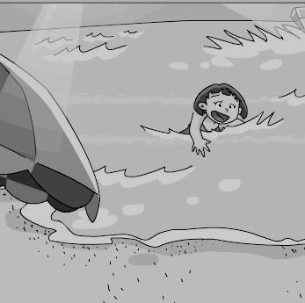
ⅨLook and write (以Summer holiday 为题写话，至少5句话) 8%
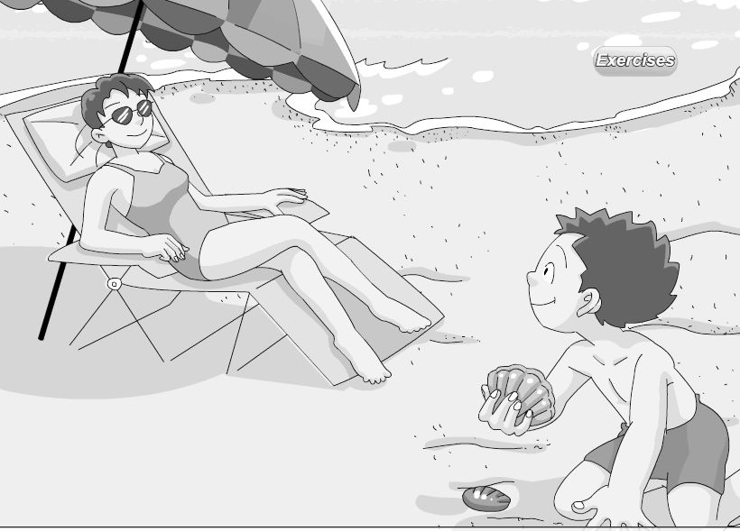
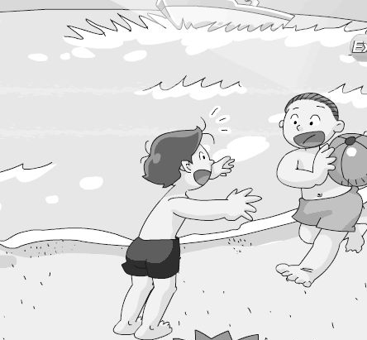
___________________
The Chens are having a holiday _____________________. ______________________________________________________________________________________________________________________________________________________________________________________________________________________________________________________________________________________________________________________

听力部分
ⅠListen and choose (听录音，选出听到的内容)
- There’s a new volleyball club in our school.
- Sam likes eating bones.
- Look! Ginger is catching a mouse.
- Peter is making a model ship in his bedroom.
- Now my grandmother is telling me a fairy tale.
- Playing table tennis is his favourite sport.
- The swimsuit cannot be too big or too small.
- The mouse climbs onto a door.
- I usually read storybooks before bedtime.
- Where’s Paul?
ⅡListen and choose (选出听到的单词的反义词)
1. A rabbit has two small red eyes.
2. The boys are playing football in the playground. How happy they are!
3. Please put the gifts in front of the Christmas tree.
4. The fat cat cannot climb onto the door.
5. The mouse is hungry, so he eats the food.
ⅢListen and choose the best answer(听录音，选择正确的应答句)
1. Does Sally like playing badminton?
2. Where is Mr Chen?
3. Is Peter collecting shells on the beach?
4. Would you like to join us?
5. I like playing basketball.
ⅣListen and judge(听录音，判断下列句子是否与听到的内容相符，相符的用“T”表示，不符的用“F”表示)
Ben has a cute pet. Its name is Sam. It is white and grey. It has two small eyes and two long ears. Its hair is long and soft. It can swim very well. It likes eating bones and meat. It likes drinking milk. But it doesn’t like cats. Ben likes playing with his pet Sam.

ⅤListen and fill in the blanks(听录音，填入正确的单词 )
Milly is a mouse. He is small. He is looking at an apple in the tree. But the tree is very tall. Ella is an elephant. He is big and strong. He wants to help Milly. Look! He is shaking the tree. The apple is falling. Milly can have the apple. Now Milly is eating the apple. He is happy. Ella is eating some leaves. He feels happy too.

