Exercises for Module 1 Unit 2（5A）
Class_________ Name ________ No. ____

I. 听写句子
- ____________________________________________________________
- ____________________________________________________________
- ____________________________________________________________

II.语音判断，将不含有所给音标的单词的编号写在前面的括号内
( ) 1. /æ/ A. any B. had C. apple
( ) 2. /e/ A. English B. head C. stretch
( ) 3. /ʌ/ A. cut B. but C. cute
( ) 4. /ei/ A. fat B. face C. whale

III.根据例句填入正确的内容。
Eg: My room isn’t big. It’s small.
1. My father is a tall man. But my mother is ____________.
2. Don’t be __________. Be happy, please.
3. Look at this new knife. It’s not sharp. It’s ___________.
4. It’s not early. It’s ________ at night.
5. Are these swans ugly? No, they are ________________.
Eg: The boys are playing football now.
- Are you reading? No, we ______________. (write )
- Tom _____________ in the classroom. (sit )
- Is your father running? No, he ____________. (jump )
- What are you doing now? I ______________. (dance)
- Look! Danny ______________ his bicycle in the playground. (ride )

Ⅳ. 用to ,for, from…to, at, by填空，每词限用一次
1. My father runs ________ home ____________the street garden every morning.
2. --- Can we take underground ____________Nanjing Road? --- Yes, we can.
3. We can’t cross the road now. Let’s wait __________the green light.
4. How do you go to school? I go to school ___________bike.
5. --- When does Amy leave school? --- She leaves school _____half past three.

V.根据图意完成句子，每线一词
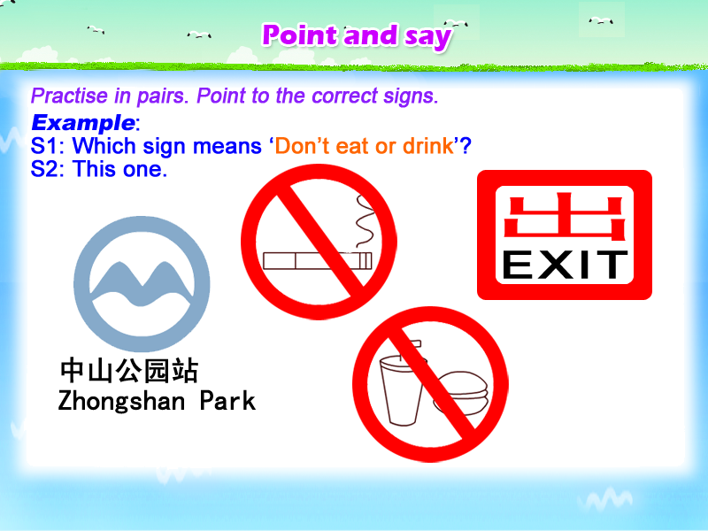 | 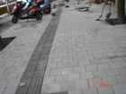 | 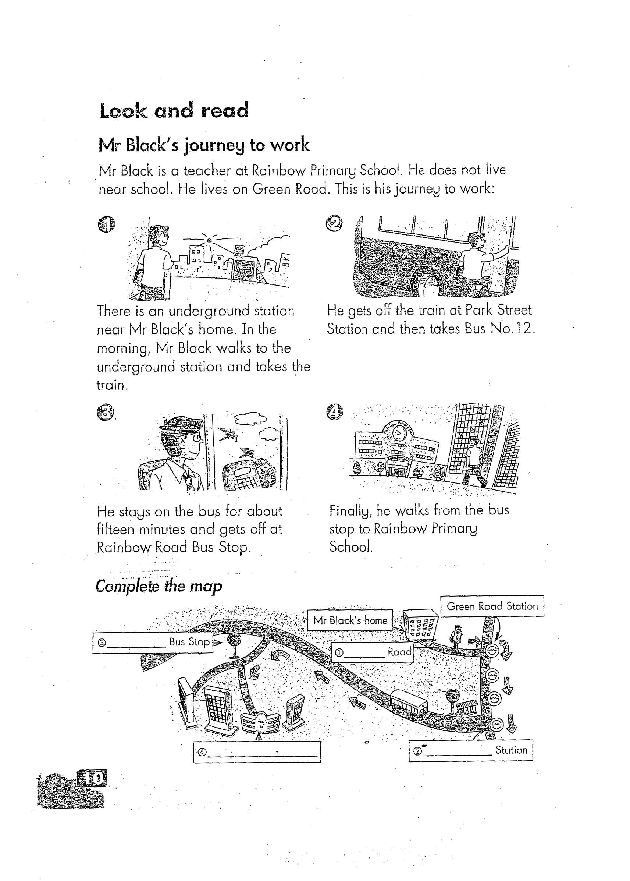 | 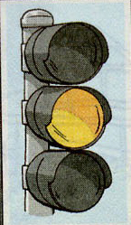 | 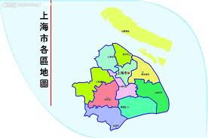 | 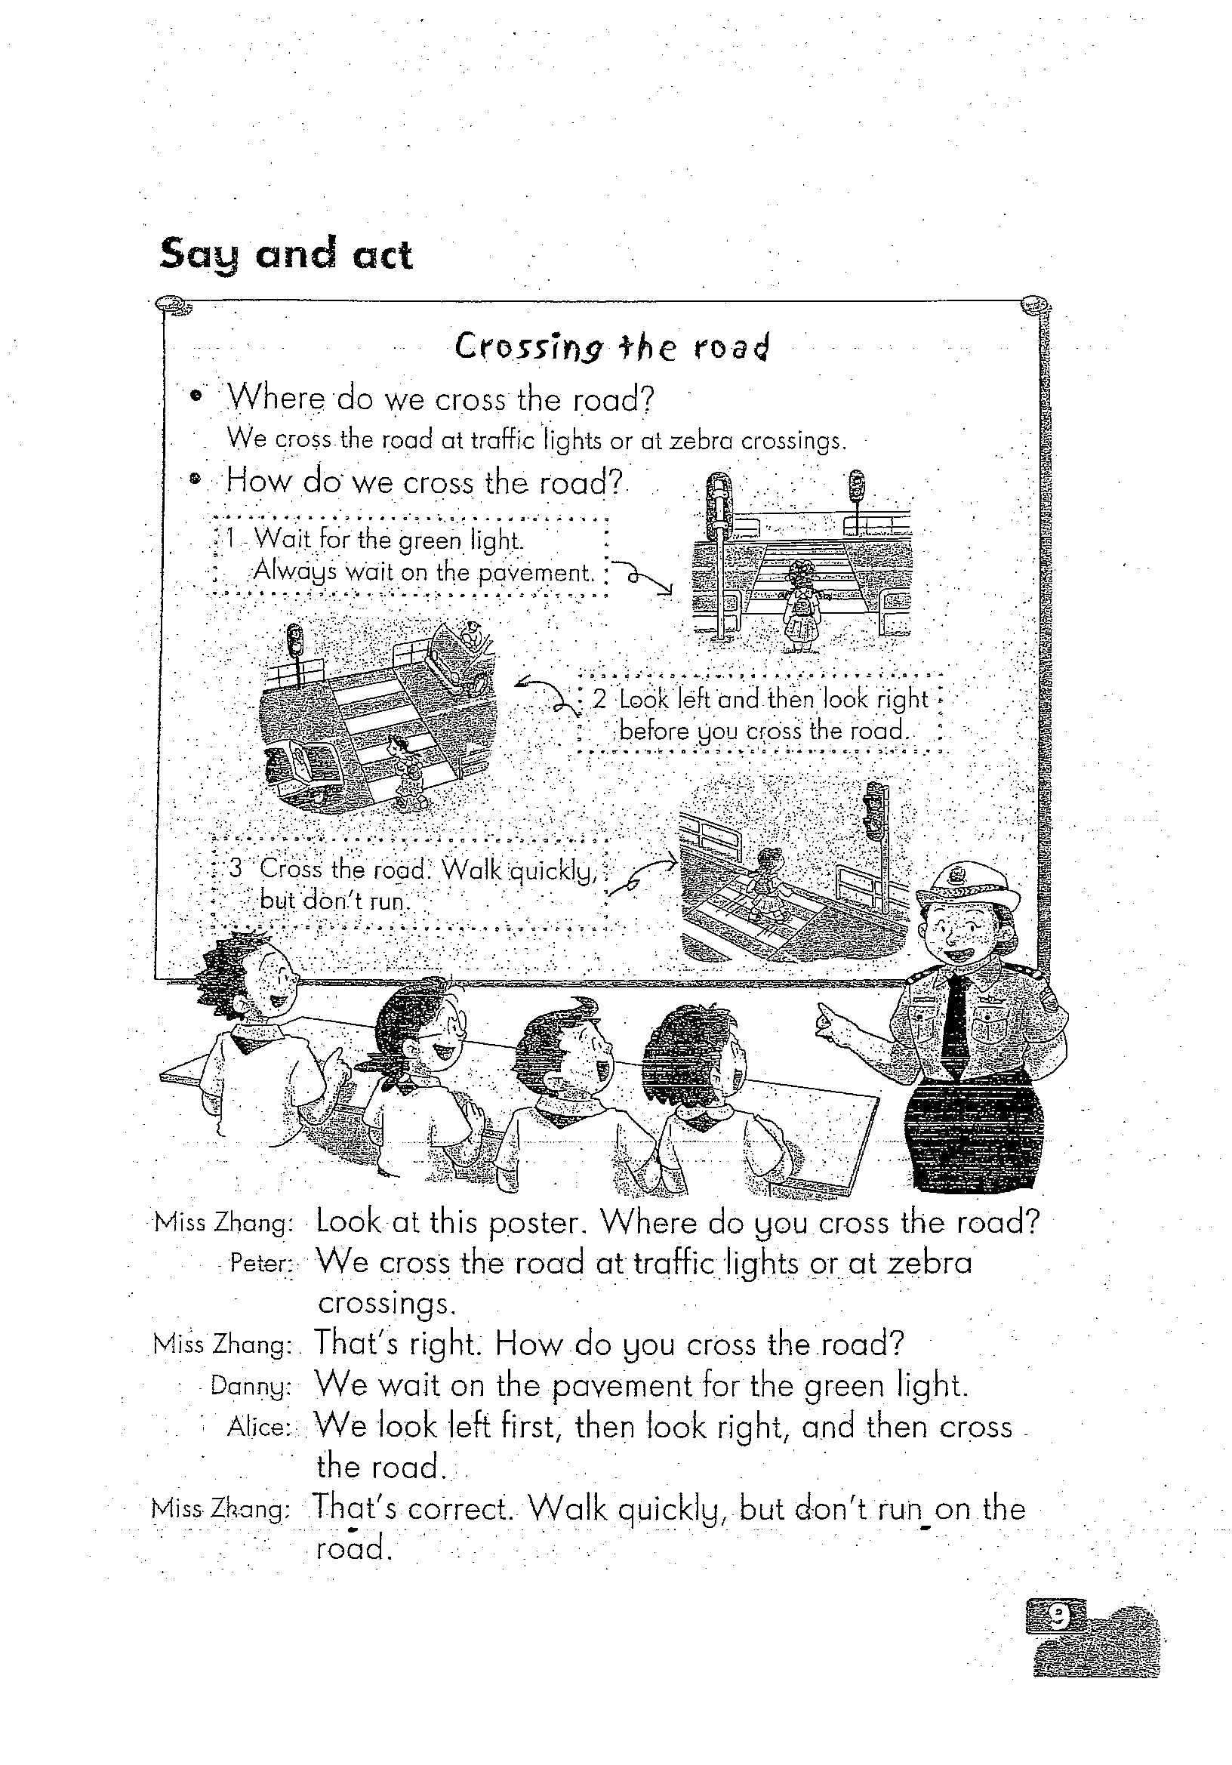
(1) | (2) | (3) | (4) | (5) | (6)
1. We are waiting for the train at the underground ________________.
2. Walk quickly on the _____________.
3. When you take the bus. ___________ on the bus quickly.
4. When the traffic _____________ is yellow. Please get ready.
5. This is a ____________ of Shanghai.
6. Miss Zhang is a ___________officer.

VI. 用动词的适当形式填空
- Kally _______ (get) up at 7:00 every Sunday.
It’s Sunday today. Now she ______________(get ) up.
- Oh, here’s Kitty. She ___________( fly) a kite. ____________(look), she ____________(hold) the kite in her hands now. She __________(like) flying kites very much.
- John __________(run) now. And the geese ____________ (swim) on the lake.
- My mother ______________ (wash ) the dishes in the kitchen now.
- Please _________________ (have) some water.
- School is over. The pupils can ___________ (play) games.
- Don’t ____________ (run ) in the school, Danny.
- We ____________ (like ) music. Now we _____________ (sing)
- Let me ___________ (go) to the cinema.
- Mary, _________ you __________ (clean) the window? Yes, I am.
- The workers _____________ (want) some tea. They’re thirsty.
- Look, Mr White ___________ (have) a maths lesson. We like maths.

VII．阅读
Bill and Sue are brother and sister. They are both middle school students and go to the same school.
They go to Miss Chen’s shop and see some nice rabbits. They love the rabbits very much, but they have no money to buy them.
Sue has a good idea. She and Bill help their father pick apples on the farm every Saturday and Sunday. Their father gives them each a hundred dollars.
Sue and Bill go to Miss Chen’s shop. Each of them buys a rabbit. One is white and the other is black. They call the black rabbit Bunny and the white one Judy. They like them very much.
Do “T” or “F”
1. ( ) Bill and Sue are brothers. 2. ( ) They study in different school.
3. ( ) They like rabbits. 4. ( ) They buy one rabbit in a shop.
VIII．根据短文回答问题：
- Do they love the rabbits very much? ____________________________
- What do Bill and Sue do every Saturday and Sunday?
_________________________________________________________
- How much money does their father give them?
__________________________________________________________
- What colour are two rabbits?____________________________________
- What’s the black rabbit’s name?__________________________________
- What’s the white rabbit’s name?__________________________________

IX．回答问题
1. Where do you cross the road?
We cross the road at _________________ or at _______________________.
2. How do we cross the road ?
We ________on the ________ for the green light. We look ______first, then look ________, and then _______ the road.
3. When is your birthday? ___________________________________________
4. How do you come to school? _______________________________________
5. When do you arrive at school? ______________________________________
6. What’s the weather like today? ______________________________________
7. What are you doing ? ____________________________________________
8. How many pencils do you have? ____________________________________
9. What time do you go to bed at night? _________________________________
10. What’s your favourite colour? _____________________________________

