Exercise for M3U1 (5B)
Class________ Name_________ No ________

- 写出与所给的单词划线部分发音相同的单词
- look _______ ________ 2. read _______ ________
  - your ______ ________ 4. when _______ ________

二．根据中文提示完成句子
1. My grandfather_________________ (遛他的狗) in the garden every morning.
2. Look at the sign. You _____________________（不应该踢足球）here.
3. What is Kitty doing? She ____________________（野餐）with her friends..
4. You mustn’t ___________________________（摘花）in the park.
5. We _______________________________（要从这里出去）. Where is the exit?
6. Did they ______________________(找到回家的路) at last?

三．用单词的适当形式填空
1. What does the sign ________ (say) ? It says ‘No ______________ (park).’
2. The park_________(keep) didn’t allow __________ (we) to pick the flower..
3. Don’t ______________ (throw) the paper on the ground.
4.Look at the _________ (child). They ______________ (play) basketball there.
5. The stepmother didn’t _______(like) the brothers.
She ________ (take) them to the forest.
6. He says he’ll come back _____________ (late).
7. My mother ______________ (wash ) the plate in the kitchen now.
8. Please _________________ (have) some water.
9. Look, Mr White ___________ (have) a maths lesson. We like maths.
10.Yesterday they _________( have) a party. It ________ (be) a great party..
11. Tom can’t ________ (skate) on the ice, but he likes __________(swim) in winter.
12. Whose ___________ (lorry) are those? Sorry, I don’t know.

四．选择填空
( ) 1. The sign says ‘Don’t _______rubbish here’.
A. throw B. throwing C. dropping
( ) 2.How do you go _______ the park? We walk _______ there.
A. to, into B. into, to C. to, /
( ) 3. Look at the sign. It says ‘No ________ ’. We can’t swim here.
A. swimming B. swim C. swam
( ) 4. It’s time for class. We ________ be quiet.
A. mustn’t B. must C.shouldn’t
( ) 5. No _______ ! A. smokes B.smoke C. smoking
( ) 6. You _______ swim in the river. It’s dangerous.
A. mustn’t B.don’t C. must
( ) 7. You_____ go home today. Your mother is waiting for you.
A. should B.shouldn’t C. mustn’t
( ) 8. Look at the sign! We ________ have a picnic here.
A. What B. How C. Where
( )9. Shall we stay at home and _______ TV today?
A. see B. watch C. look at
( )10. I want to go home now. Where is the ______ here?
A. exit B. entrance C. office

五. 按要求改写句子
1. We must walk our dogs here. （否定句）
__________________________________________________________________
2. Gretel dropped the stones on the road.（提问）
____________________________________________________________________
3. The park keeper comes. (一般疑问句）
____________________________________________________________________
4. The police officer means we must stop our car.（划线部分提问）
___________________________________________________________________
5. Don’t smkoe! （换一种说法）
____________________________________________________________________
6. My sister saw a film last week.（把last 改为every）
____________________________________________________________________

六． 用下列单词填空
can/ can’t, must/ mustn’t, should/ shouldn’t , shall
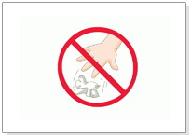
1. _________ you ride a bicycle? Yes, I _______.
2. You _________eat some fruit and vegetables every day. It’s good for your health.
3. We ___________ play with fires. It’s dangerous.
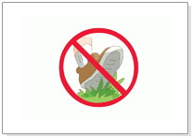
4. __________ I put my bag here? Yes, you can.
5. ___________we go to the cinema this evening? God idea.
6. You ____________ eat so much meat. You will be very fat.
7. You __________ park your car her. Look at the sign.
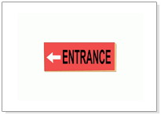
8. We ________ walk on the pavement.
9. You have a bad cold. You _________ see the doctor.
10. We _________have a rest here. It’s cool under the tree.

八. 选择适当的短语，填空完成对话
. A. in the afternoon B. What about you, Paul C. He’s very funny.
D. What do you do E. with Mum and Dad F. I go for a picnic
G. What else H. I play on the computer
-- __________________ on Saturday, Linda?
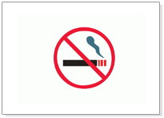
-- Well, sometimes I go to the cinema.
-- Who do you go with?
-- I go _________________________.
-- Sometimes ___________________ with my aunt and uncle.
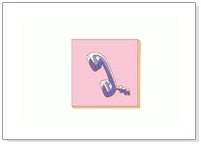
______________________________________________
-- In the morning, I play football with my friends.
-- What do you do __________________?
--Sometimes I go shopping with Mum. Sometimes _________________________.
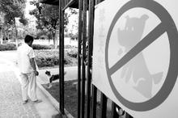
-- Anything else?
-- Sometimes I go to my uncle’s house. __________________.
We tell stories and play games.

九．根据标志，回答问题

1. What does this sign mean?
___________________________________________________

2. What does this sign mean?
__________________________________________________

3. What does this sign say?
___________________________________________________
4. What does this sign mean?
___________________________________________________

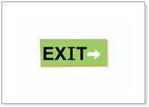
5. What does this sign say?
___________________________________________________
6. What does this sign mean?
___________________________________________________

7. What dose this sign mean?
___________________________________________________

8. What does this sign mean?
___________________________________________________

9. What does this sign mean?
__________________________________________________

